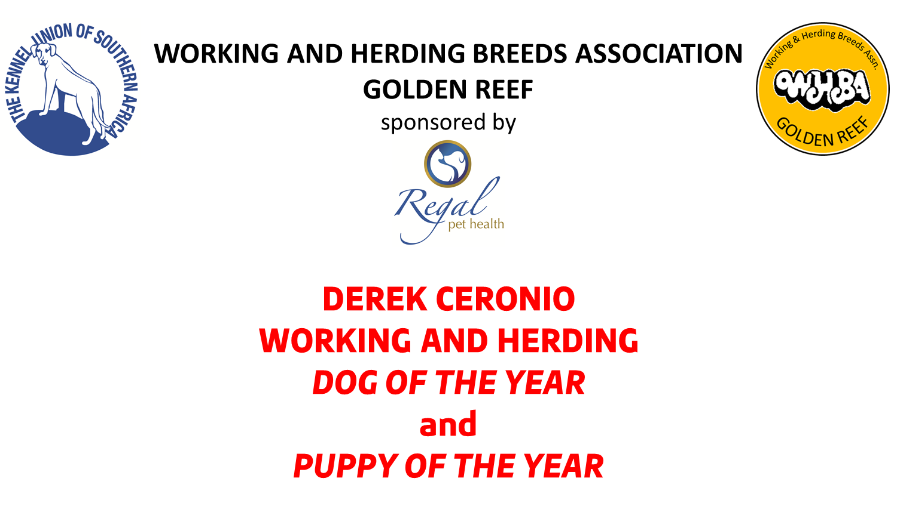

JUDGE: MR BRUCE JENKINS

DATE & TIME | Sunday, 18 August 2019 (after Best in Show)
CLOSING DATE | 12 AUGUST 2019
ENQUIRIES | Cathy Young 0834687970 | Jonelle Kuyler 0733286638
ENTRIES | R50.00
QUALIFYING CRITERIA | Any WORKING and HERDING dog and bitch to have won the highest number of BEST OF BREED and RESERVE BEST OF BREED and BEST PUPPY awards in GAUTENG, during the period 20 August 2018 to 12 August 2019.  The highest number of points in each breed qualifies. Highest number of Best Puppy awards qualifies.
ENTRIES | Please fill in and submit the separate form. DO NOT SEND copies of the Best of Breed/Best Puppy Certificates – we will request them if necessary.

DEREK CERONIO W&H PUPPY OF THE YEAR TO FOLLOW BEST IN SHOW
DEREK CERONIO W&H DOG OF THE YEAR TO FOLLOW W&H PUPPY

Pull-outs for Working & Herding Groups MR BRUCE JENKINS
Working & Herding Dog & Puppy of the Year MR BRUCE JENKINS

This show is held under the Rules and Regulations of the Kennel Union of Southern Africa. SCH (3) REG 5.9.
RIGHT OF ADMISSION RESERVED

