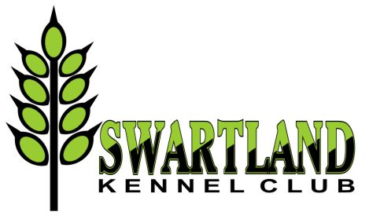

SWARTLAND KENNEL CLUB

NOTICE OF THE ANNUAL GENERAL MEETING

Notice is hereby given that the Annual General Meeting will take place as follows:

Date: Sunday 23 April 2017
Time: Immediately after conclusion of BIS at Overberg KC Open show
Venue: Jagtershof Rugby Club

AGENDA

1. Notice convening the Meeting
2. Apologies
3. Matters arising
4. Chairman’s Report
5. Treasurer’s Report
6. Items submitted by the Committee
7. Items submitted by the Members - any other business of which due notice has been given in writing to the Secretary 14 days prior to the meeting
8. Election of Committee and nominations
9. General

OFFICE BEARERS

President: Mervyn Heroldt

COMMITTEE

Chairman: Joy McFarlane
Vice Chairman: Kerstin Fehrsen
Secretary: Elrena Stadler
Treasurer: Heather Gould
Committee: Anja le Roux, Neil de Kock, Adri Els, Stephenette du Toit, Lariska Els,
Janet Wang

The term of office of each member is one year

Only paid-up members will be able to vote. Membership fee: Single R10 pa, Family R15 pa

The Secretary

Elrena Stadler: 083 457 2659 or (022) 433 3360
elrena@showdogs.co.za

