THE CAVALIER KING CHARLES SPANIEL CLUB
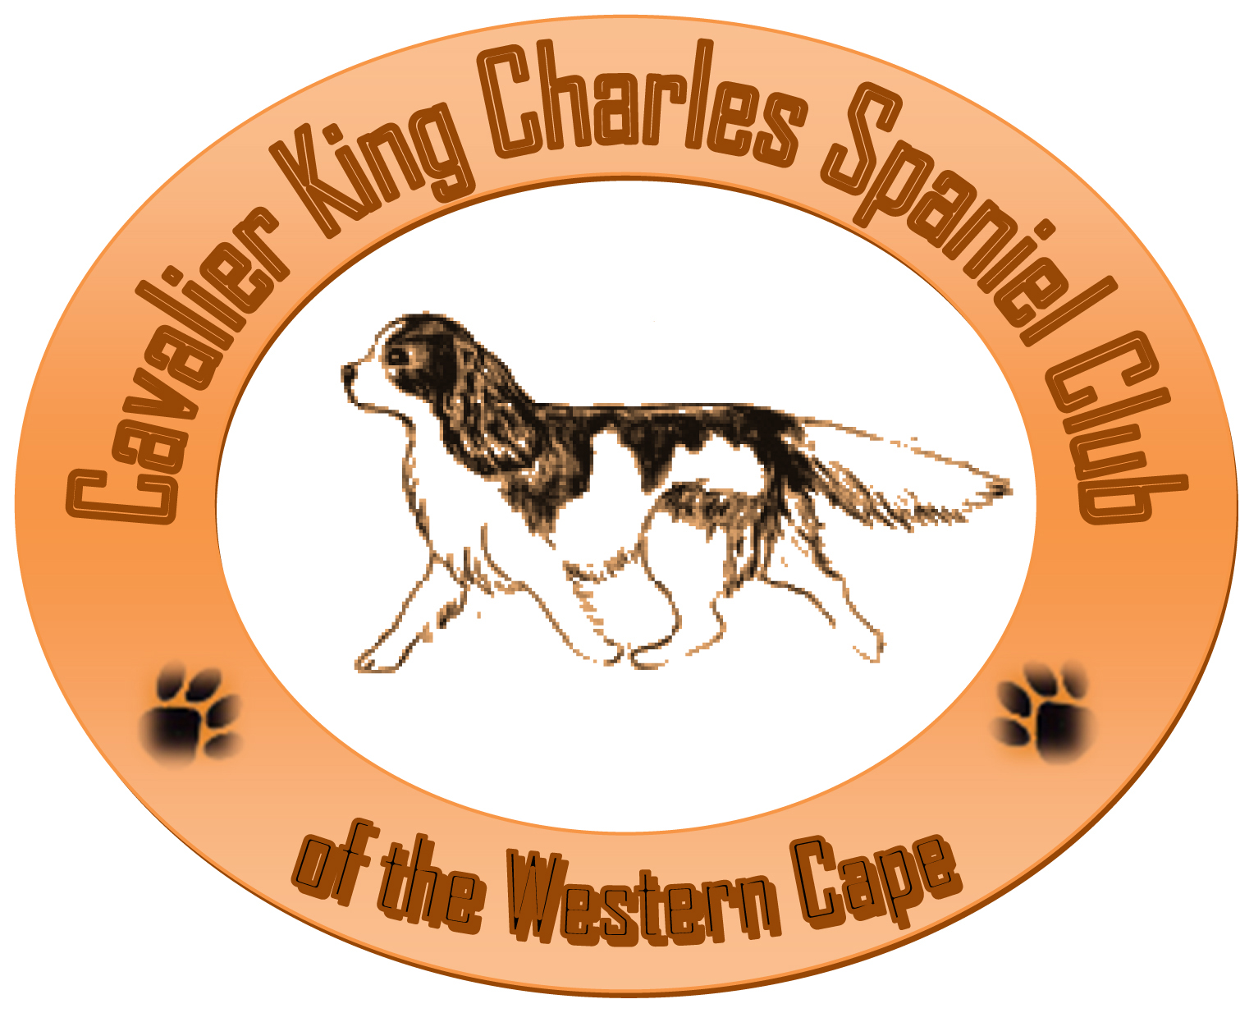
OF THE WESTERN CAPE
Affiliated to the Kennel Union of Southern Africa
P. O. Box 28215 - BOTHASIG - 7406
secretary@cavalierswesterncape.co.za

Non – Championship Show Schedule 2015
Breed and Agility (contact and non –contact)

Date: Saturday 12th September 2015

Venue: Cape Handlers, Theo Marais Park,
Koeberg Rd, Milnerton.

Time: Agility - 09:00
Breed - 12:00

Show Manager: Mr. D. Branquinho

Enquiries: Mrs. P. A. Upton (021 558 6040)

Entry Fees – Postal/E-Mail: R40.00 per dog per class (Proof of payment to accompany entries)
R15.00 per additional discipline / class (same dog) (Agility only)

AGILITY POSTAL / EMAILED ENTRIES ONLY

Postal Entries Close: Friday 26th August 2015

Entry Fee on the day: R45.00 per dog per class
R25.00 per additional dog – Breed – Members Only
(Taken From 08-30) R25.00 per additional class – Agility

Entries to: Secretary, Cavalier King Charles Spaniel Club of the Western Cape
P. O. Box 28215, Bothasig, 7406.
FAX: 086 542 5510 Email: secretary@cavalierswesterncape.co.za
Banking Details: Cavalier King Charles Spaniel Club of the Western Cape
ABSA – N1 City BRANCH CODE 420410
ACCOUNT NUMBER: 9105287334

Breed Classes: Baby Puppy (4-6 Months) Minor Puppy, (6-9 months), Puppy, (9-12 months),
Junior (12-18 months), Graduate (18-24 months), S A Bred, Veteran (+7 years), Open and Champion and best Neuter Dog.
Note: Neuter Dogs qualify for Best Neuter Dog in Show and not Best in Show.
Only entries on KUSA official show entry form will be accepted. Each dog entered must be on a separate entry form.

JUDGES
Breed Mrs. Stephenette Du Toit
Agility – Contact & Non-Contact – All Classes Mrs. Marizelle Strydom

STEWARD
Breed Mr. R. Upton

This show will be held under the rules and regulations of the Kennel Union of Southern Africa. Schedule 3 applies: “All exhibitors are personally responsible for the control of their dogs at all times and shall be personally liable for any claims which may be made in respect of injuries which may arise or be caused by their dogs.” Bitches in season are allowed in the breed ring only.
Right of admission reserved. No Alcohol to be brought on the premises.
THIS SHOW IS SPONSORED BY

