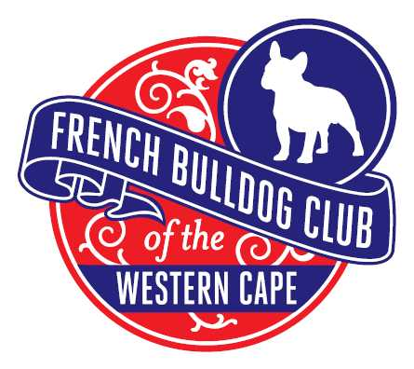
The French Bulldog Club

of the Western Cape
3rd Annual Championship Show Schedule

Date : Saturday, 17 September 2016
Time : Breed judging commences @ 14h00
Venue : Cape Handlers Dog Club
Theo Marais Park, Koeberg Road, Milnerton
Breed Judge : Mr Mark Simpson (South Africa)
Show Manager : Peter Thornhill
Breed Steward : Celeste MacLeod Barlow
Vet on Call : Panorama Veterinary 24Hr Hospital/ Dr Conrad Prins
Catering : Available at Venue
Enquiries : The Show Secretary
Lori Kasselman
BABANK DETAILS
ABSA
Branch 632005
Acc No 9261329226
Cell 082 9900081
Email Kasselman@telkomsa.net
Entry Fee : R90 per entry for BREED CLASSES
R10 per BREED CHALLENGE CLASS
ENTRIES CLOSE ON
2 SEPTEMBER 2015
NO ENTRIES ACCEPTED ON THE DAY OF THE SHOW

Payment directly into bank account please
No cheques accepted for entries

BREED CLASSES CHALLENGE CLASSES
Baby Puppy 4 – under six months (not eligible for CC) Dam/Sire Progeny
Minor Puppy 6 - 9 months Brace
Puppy 9 -12 months Members
Junior 12-18 months
Maiden Never been placed 1st at a show
Graduate 18- 24 months
SA Bred Dog must have been bred within South Africa
Neutered Dogs (not eligible for CC)
Veterans 7 years and older
Open Unrestricted
Champions Champion Dogs Only

The French Bulldog Club

of the Western Cape
3rd Annual Championship Show Schedule

AGILITY
Start time will be communicated to all Exhibitors closer to show date as it will follow on from the Cape Bulldog Club Show in the morning.
Judge: Deidre van Coller
ENTRY FEE: R25.00 per class

Entries and Proof of Payment to
Kasselman@telkomsa.net

Closing date 2 September 2015

CONTACT SMALL 1 2 3
MEDIUM 1 2 3
LARGE 1 2 3

NON CONTACT SMALL 1 2 3
MEDIUM 1 2 3
LARGE 1 2 3

This show will be held under the Rules and Regulations of the Kennel Union of Southern Africa.
All Exhibitors/Handlers are personally responsible for the control of their dogs at all times and shall be personally liable for any claims which may be made in respect of injuries which may arise or be caused by their dogs.
Dogs must be registered with Kennel Union of South Africa
The exhibitors are responsible for safeguarding the welfare of the dog at a dog show. It is forbidden to put the dog in a situation that can be dangerous for its health and welfare, such as leaving the dog in the car in hot or cold weather and/or treating the dog in a cruel manner.
Violation of these rules will result in exclusion from the current and future dog shows"
Right of admission reserved

IMPORTANT TO NOTE:
- Please keep the sports ground and club house clean and tidy.
- All exhibitors/handlers are personal responsible for the control of their dogs at all times and shall be personally liable for any claims which may be made in respect of injuries and/or damage which may arise or be caused by their dogs.
- Dogs must be kept on a lead/leash or firmly secured at all times.

KINDLY ADHERE TO THE CAPE HANDLERS DOG CLUB RULES

NO PRIVATE LIQUOR TO BE BROUGHT ONTO THE PREMISES

The Theo Marais Sports Ground has a liquor licence that is extended to all of the Sports Clubs on the precinct. The CHDC is obliged to respect the rules of the management of the Sports Grounds.

DOGS ARE NOT ALLOWED ON ANY FIELD OTHER THAN CAPE HANDLERS

Complaints have been received from the baseball and rugby club pertaining to people not cleaning up after their dogs, so please ensure your dogs remain on the CHDC grounds.

PARKING ONLY PERMITTED BEHIND THE LOG BARRIERS

Kindly ensure that ALL vehicles are parked behind the log barriers around the field. Parking on the grass surrounding the ring will not be allowed.

DOGS ARE NOT ALLOWED IN THE CLUB HOUSE
The grassed area within the fence of the Clubhouse is a children’s’ play area. Please respect the rules and do not take your dogs into this area or into the clubhouse.

