THE WORKING AND HERDING BREEDS CLUB OF THE CAPE

THIRTY-THIRD CHAMPIONSHIP SHOW
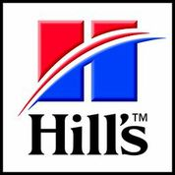
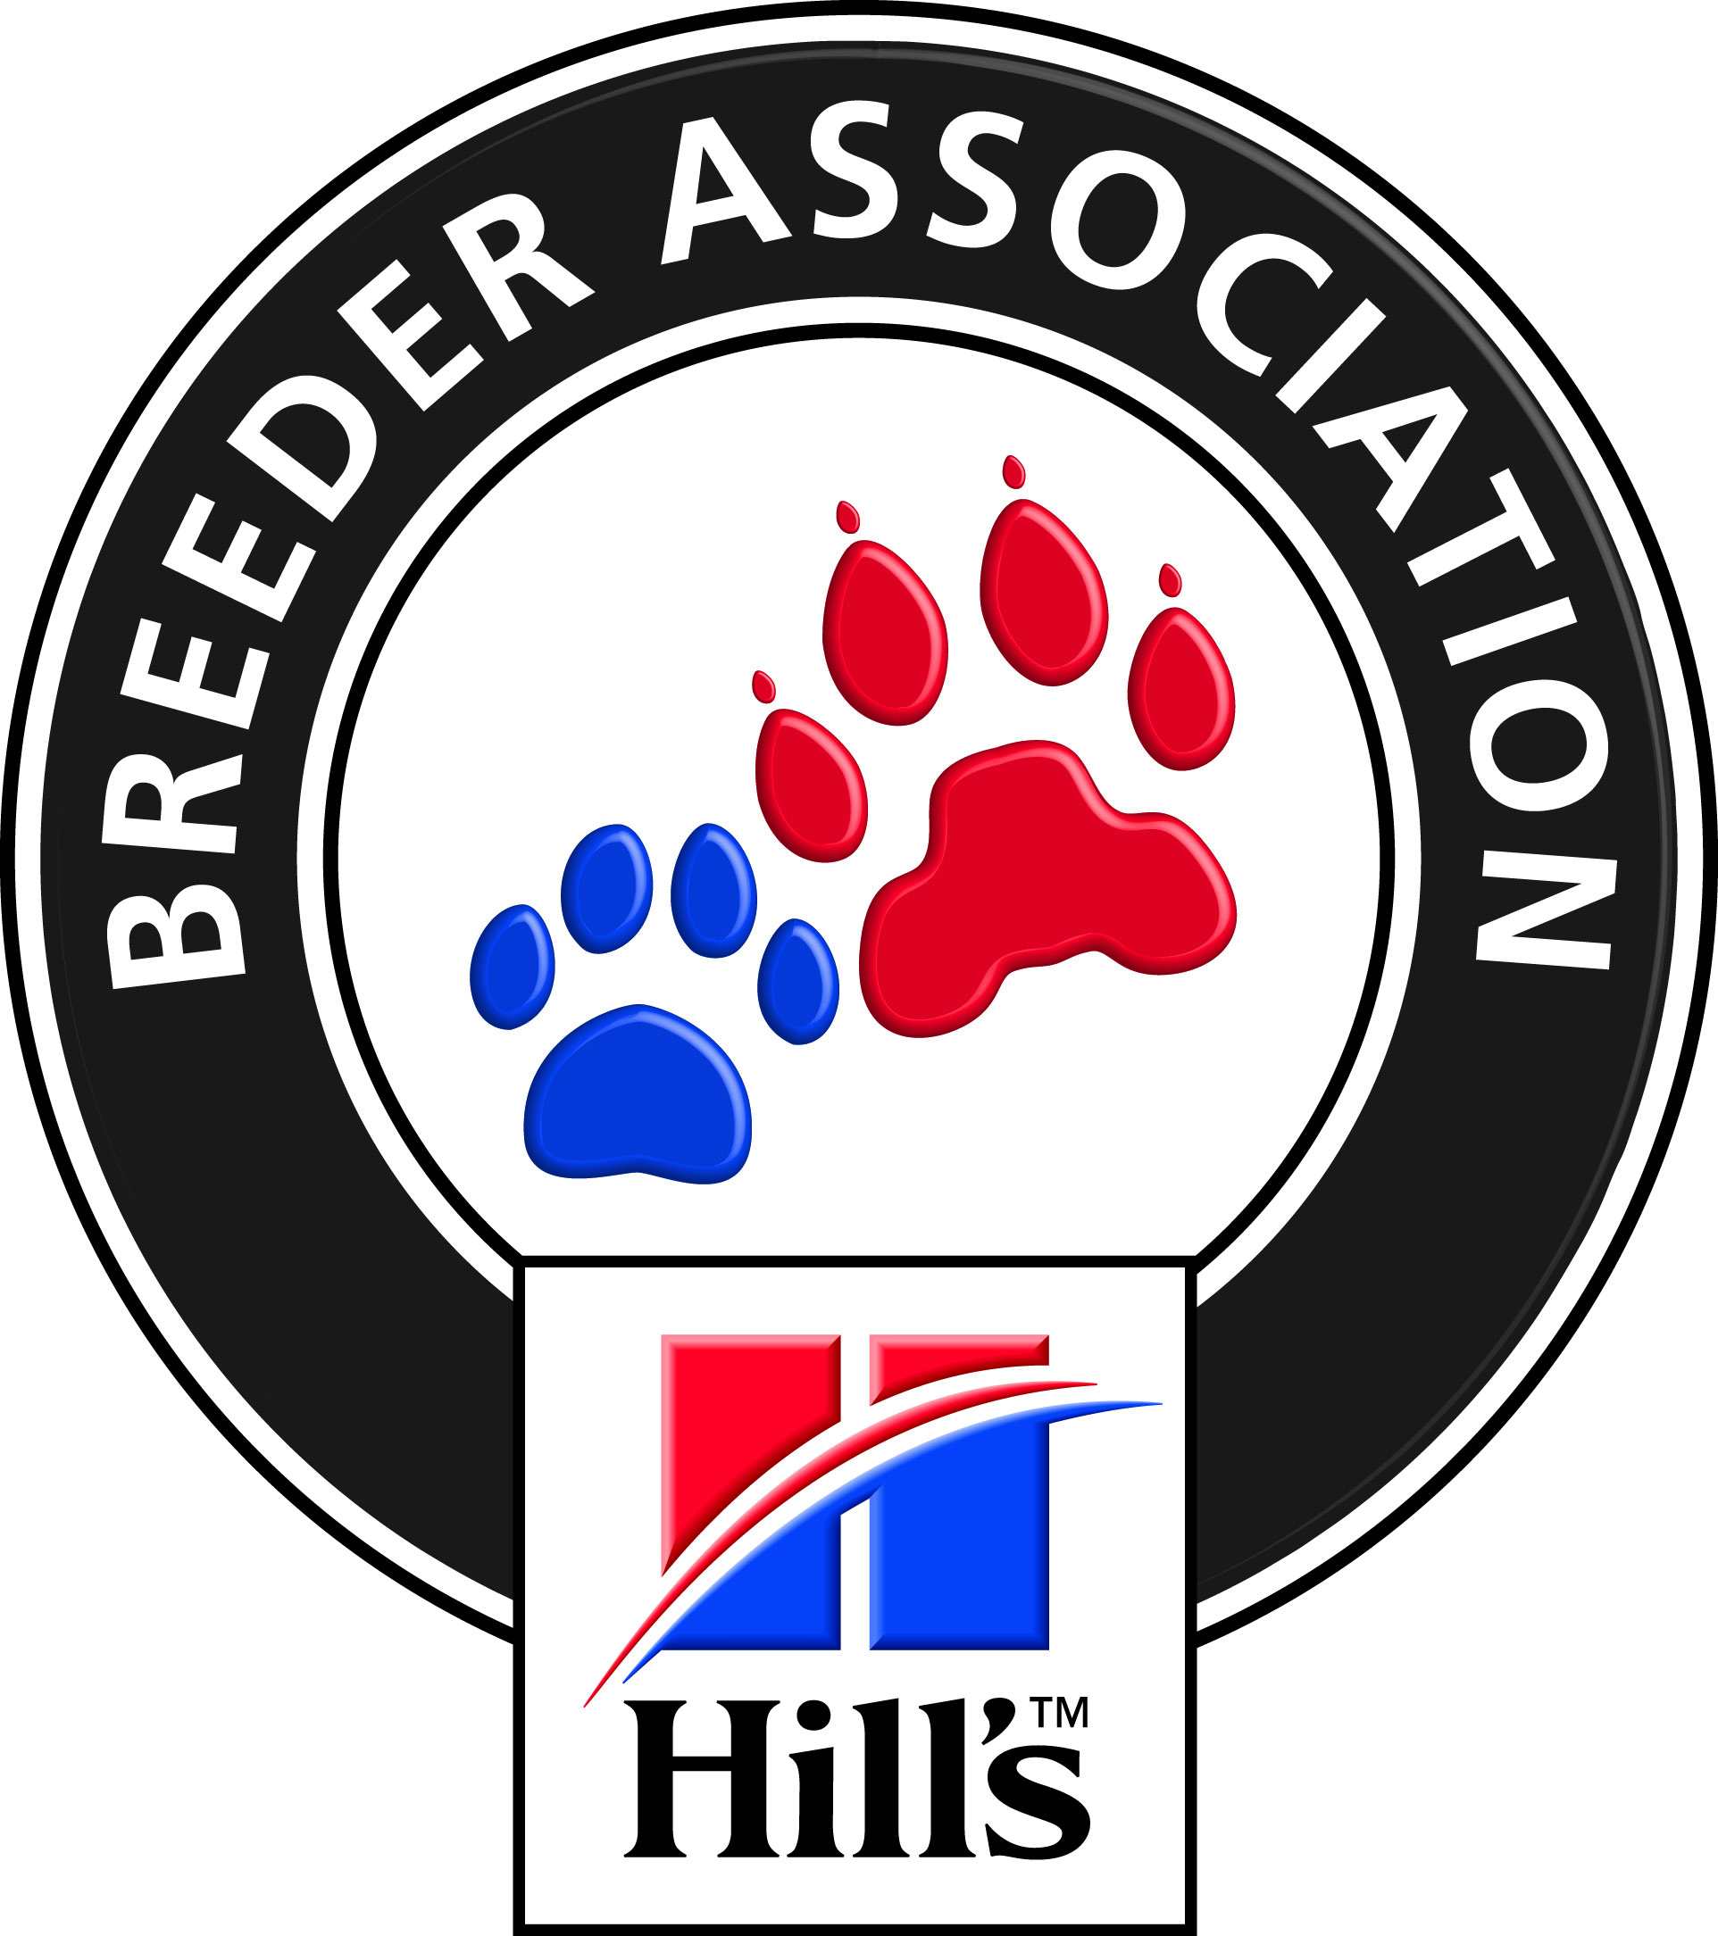

FRIDAY 21st OCTOBER 2016

AT THE BRACKENFELL CRICKET CLUB, BRACKENFELL

JUDGES BREED:  DOG JUMPING  OBEDIENCE  Entries Close | HERDING – Best NEUT/PU/JU/VET/BIS Mr G Bidder 10H00  PLEASE NOTE: WHITE SWISS SHEPHERDS to be judged first  WORKING Mrs G Cook (Australia) 10H00  Dog Jumping Table A: All Classes Mrs M Sparks 08H00  Obedience Class “B” and “C” Mr J Marques 08H00  Flyball (29th Oct 2016 at CAPE HANDLERS) Mr T v d Vyver 08H00  6 October 2016. Faxed or e-mailed entries must be accompanied by proof of payment.  Money deposited will not be refunded
Please note  Entry Fees Breed and Qualifying Discipline  Classes  NON-QUALIFYING  CLASSES  CATALOGUES | PLEASE ADD R 20-00 TO CASH AND CHEQUE PAYMENTS  TO COVER BANK CHARGES. Thank you.  PLEASE USE SURNAME AS REFERENCE ON PAYMENT.  Non-Members R 100-00 per dog per first class R 65-00 per additional class  Members R 95-00 per dog per first class R 60-00 per additional class  R 100-00 per Flyball team PAY AS A TEAM NOT AS INDIVIDUALS  R 45-00 per dog ( NEUTER & DISCIPLINES)  MEMBERSHIP: - R20.00 PER FAMILY AND R15.00 PER SINGLE MEMBER  R 25-00 (Group only) to be ordered and paid for with entries.
Entries & Enquiries: | Hon Secretary, Mrs Hella Fricke: Tel: 076 170 7218 Fax: 086 218 9877  P O Box 59, Koelenhof 7605 e-mail: whbc@telkomsa.net
Banking details: | ABSA , Santyger, Branch Code 632005, Savings Account No: 909 484 0695
Show Manager: | Mr. R Koning
Vet on call: | Dr le Roux, Brackenfell
KUSA Rep | Mrs D E Powell
Breed Classes: | Minor Puppy (6-9 months) Puppy (9-12 months) Junior (12 – 18 months) Graduate (18 – 24 months) S A Bred Veteran (7 years +)  Open Champions Neutered  PLEASE NOTE: There is NO BABY-PUPPY CLASS
Judging order GROUP/BIS | BEST NEUTER / BEST PUPPY / BEST JUNIOR / BEST VET / GROUP - BEST IN SHOW
BITCHES IN SEASON are allowed only in the BREED and DOG JUMPING areas
All Exhibitors/Handlers are personally responsible for the control of their dogs at all times and shall be personally liable for
any claims which may be made in respect of injuries which may arise or be caused by their dogs
SPONSORED BY
Hill’s Pet Nutrition

