The Collie Club of South Africa
Open Show
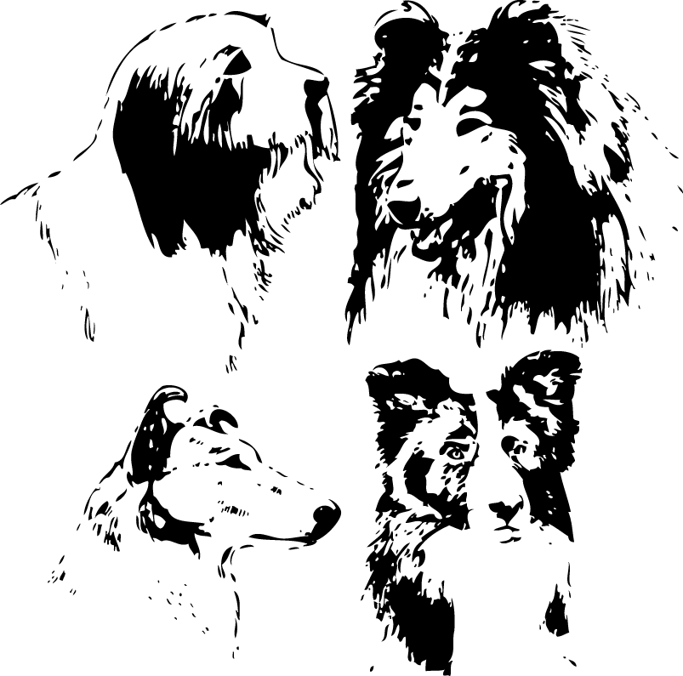
Sunday 2 October, Goldfields Grounds

AGILITY (CONTACT & NON-CONTACT) – ROB HALL
DOG JUMPING – SUE VD PIJPEKAMP
09H00

ENTRY FEES: R40 PER CLASS. R100 FOR ALL 3 CLASSES
(MEMBERS R35 PER CLASS. R90 FOR ALL 3 CLASSES)

BREED 14H00–JACKIE BROWNING
Bearded, Border & Rough Collies

Baby Puppy, Minor Puppy, Puppy, Junior, Graduate, Veteran, Open, Champions
Challenges: Child Handler, Junior Handler, Gait, Novice Dog, Brace
Best Expression

ENTRY FEES: R40 PER CLASS (MEMBERS R35 PER CLASS)
CHALLENGES @ R10

Bitches in season are allowed in the breed classes only
Right of admission reserved
All exhibitors are personally responsible for the control of their dogs at all times and shall be personally liable for any claims which may be made in respect of injuries which may arise or be caused by their dogs

ENQUIRIES: GLENDA DE TARANTO: 083 312 1038 or 011 802 4432

