BOXER CLUB GOLD REEF

NON CHAMPIONSHIP SHOW
Held under the rules and regulations of the Kennel Union of Southern Africa

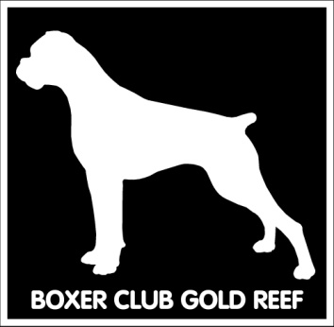SUNDAY - 19 FEBRUARY 2017
VENUE: Goldfields Show grounds, Boeing West,
BEDFORDVIEW

JUDGING: 11h00

JUDGE: MR NEIL PERKINS (GAUTENG)

CLASSES:
Baby Puppy, Minor Puppy, Puppy, Junior, Graduate, SA Bred, Veterans, Open, Champions
BEST BABY PUPPY, BEST PUPPY, BEST JUNIOR, BEST SA BRED, BEST VETERAN, BEST IN SHOW, Res BEST IN SHOW
Bitches in season will be allowed in the Breed Classes, but please have due consideration for the other competitors. Mating of bitches within the precincts of the show is forbidden.

Entries from 9h30
ENTRY FEE: R 50.00 per dog per class

Enquiries: Erna Faber 082 749 3275
maroelani@gmail.com

SHOW MANAGER: May Oosthuizen
SHOW SECRETARY: Erna Faber
All competitors and visitors attend the show entirely at their own risk. The committee and members of BOXER CLUB GOLD REEF accept no liability whatsoever.
All exhibitors/handlers are personally responsible for the control of their dogs at all times and shall be held liable for any claims that may be made in respect of injuries which may arise or be caused by their dogs.

VET ON CALL: Bedfordview Veterinary Clinic

The committee reserves the right to appoint another Judge should the above mentioned be unable to officiate.

RIGHT OF ADMISSION RESERVED

