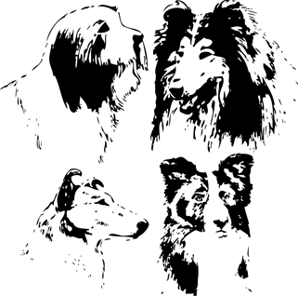
THECOLLIE CLUB OF SOUTH AFRICA
CHAMPIONSHIP SHOW
SUNDAY 15 JULY 2018
After Herding Group at EDKC
Goldfields Grounds, Johannesburg
Judge: MR ANTOAN HLEBAROV (ROMANIA)
Bearded, Border & Rough Collies
Classes: Minor Puppy (6-9 mths), Puppy (9-12 mths), Junior (12-18 mths),
Graduate (18-24mths), SA Bred, Veteran (7 yrs & over), Open,Champions,
Baby Puppy (4-6 mths), Neutered Dog
ORDER OF JUDGING: CLASSES AS ABOVE
BISs: BEST IN SHOW, BEST BABY PUPPY, BEST PUPPY,BEST JUNIOR,
BEST VETERAN, BEST NEUTER

Challenges:(R10 per class) Gait, Brace, Dam/Sire & Progeny, Best Expression
Entry Fees: R110 for first dog, R100 for subsequent dogs
Members R100 for first dog, R80 for subsequent dogs
Baby Puppy & Neutered Dogs R50 (not eligible for CCs)
NEDBANK, ACC. 1921 012 455

Entries to: collieclubsa@gmail.comFax 086 775 8949
Enquiries: Glenda 083 312 1038 or 011 802 4432
ENTRIES CLOSE 2 July. NO LATE ENTRIES PLEASE

EXHIBITORS ARE INVITED TO JOIN US FOR A DRINK AFTER THE SHOW

Show Manager: R de Taranto. Show Secretary: G de Taranto
Vet: Dr R Ehrlich.

NB: This show will be held under the rules and regulations of the Kennel Union of Southern Africa

All exhibitors are personally responsible for the control of their dogs at all times and shall be personally liable for any claims which may be may arise or be caused by their dogs

Bitches in season allowed. Please show consideration for other exhibitors

