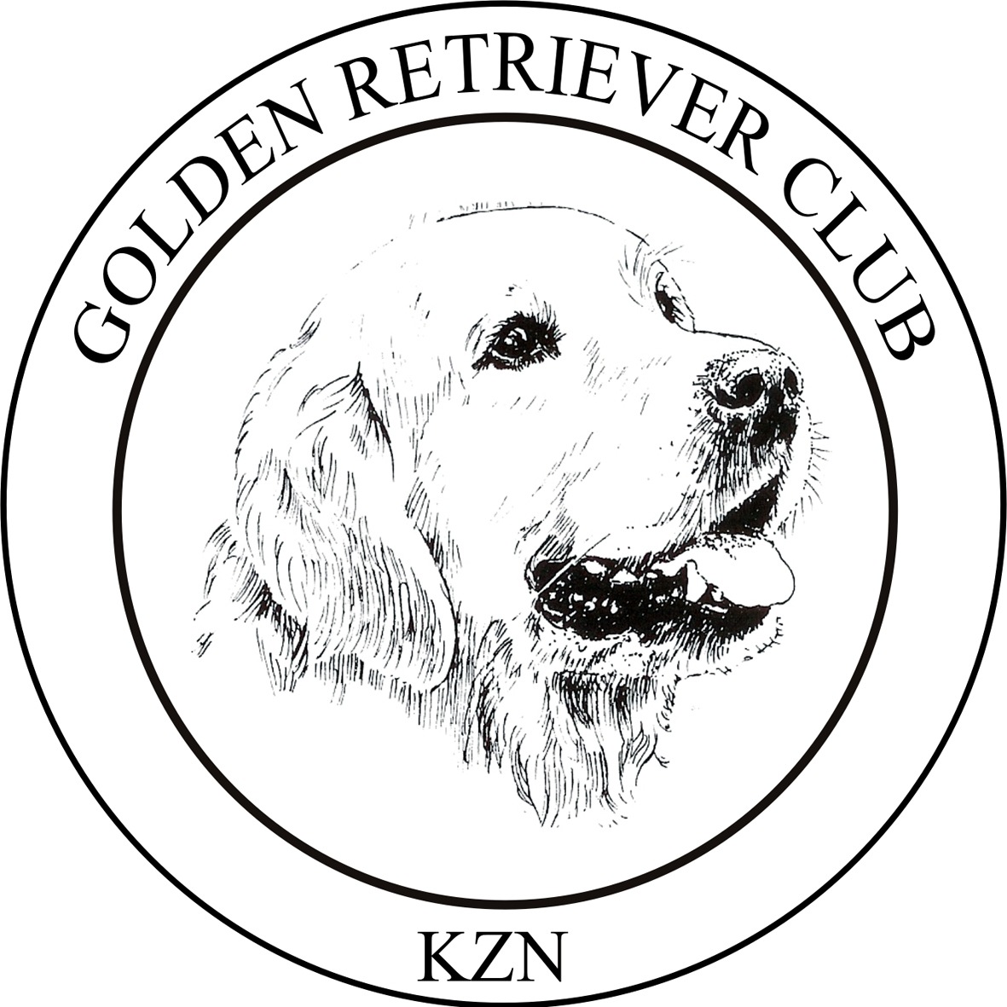
THE GOLDEN RETRIEVER CLUB of KZN
CHAMPIONSHIP BREED SHOW
Friday 6 July 2018, 2pm
At Gelofte School, Pinetown

ENTRIES CLOSE: 13th JUNE 2018

ENTRY FEES: R100.00 PER DOG
R70 Baby Puppy and Neuter Dog

CATALOGUE: R30.00

JUDGE: MRS E Knox (Australia)

CLASSES: Baby Puppy (4-6 months)* Neuter*
Minor Puppy (6-9 months) S.A. Bred
Puppy (9-12 months) Veterans
Junior (12-18 months) Open
Graduate (18-24 months) Champions
* Not Eligible for CC or BOB
Judging Order: BOB, RSBOB,Best Puppy, Best Junior, Best Veteran, Best Baby Puppy,
Best Neuter
Rosettes, Prizes and Floating Trophies will be awarded.
CHALLENGES: To be judged after judging of Best of Breeds in Show
Field Trial (dogs with FQ, placed in FT/GWT, or now active in the field)
Progeny
Brace
ENTRIES: Post to: The Treasurer, Mrs. J. Rouillard, P.O. Box 3013,
Sunningdale Cluster 1, Durban North, 4051
Email: markrr@iafrica.com or Fax 086 672 5521
Entries will be accepted if they are accompanied with a copy of the deposit slip/ internet transfer.
Cheques to be made payable to: The Golden Retriever Club of KZN
Banking Details: Standard Bank, Kloof, Account No. 050094661

Enquires Janet Rouillard 031 572 5561

SHOW MANAGER: JANET ROUILLARD

VET ON CALL: HILLCREST VETERINARY HOSPITAL

This show will be held under the Rules and Regulations of KUSA.
Bitches in season will be allowed, in the breed ring only.
ALL EXHIBITORS ARE PERSONALLY RESPONSIBLE FOR THE CONTROL OF THEIR DOGS AT ALL TIMES AND SHALL BE LIABLE FOR ANY CLAIMS IN RESPECT OF INJURIES OR DAMAGE WHICH MAY BE CAUSED BY THEIR DOGS.
RIGHT OF ADMISSION RESERVED.

