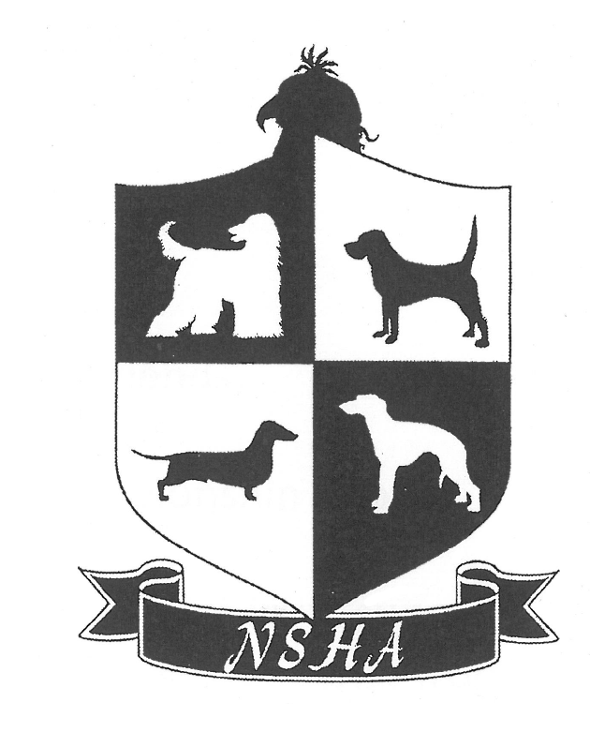
NATAL SPORTING HOUND ASSOCIATION

CHAMPIONSHIP SHOW
Venue: Gelofte Skool, 2 Caversham Rd, Ashley, Pinetown
6 JULY 2018

Entries Close: 1 July 2018
Judging Commences: 11h30
Entry Fees: R100 per dog
Neuter Dog & Baby Puppy only R60
Catalogues: R50
Marked Catalogue: After the show emailed R30

2018 MEMBERSHIP SUBSCRIPTIONS for both NSHA & ECHC
SINGLE MEMBERSHIP – R60 PER YEAR

JUDGE: MS ELRENA STADLER (Cape Town)

All Hound Breeds

Classes: Minor Puppy, Puppy, Junior, Graduate, Veteran, Open, SA Bred, Champion.
Neuter Dog, Baby Puppy – do not compete for CC or BOB

ENTRIES: Lois Wilson Email: mwsibra@mweb.co.za Fax: 0866899338
BANKING DETAILS: NATAL SPORTING HOUNDS ASSOCIATION
FNB – HILLCREST, CURRENT ACCOUNT
ACCOUNT NO.: 627 431 56 342 BRANCH NO.: 22 15 26
This show is being run in accordance with KUSA rules and regulations. Bitches in season will be allowed in the Breed Classes. All dogs are to be kept on a lead. All exhibitors/handlers are personally responsible for the control of their dogs at all times and shall be personally liable for any claims which may be made in respect of injuries which may arise or be caused by their dogs. No mating on show ground. Right of admission reserved

Enquiries:
Show Manager/Chairman: Richard Dempsey : Richard.dempsey@dempseyengineering.co.za
Show Secretary: Lois Wilson: 078 623-0826
Treasurer: Melanie Mallinger: 083 738-0013

VETERINARY SURGEON ON CALL: HILLCREST VETERINARY HOSPITAL 031 7653221

Please Note ALL EXHIBITORS/HANDLERS ARE PERSONALLY RESPONSIBLE FOR CONTROL OF THEIR DOGS AT ALL TIMES, AND SHALL BE PERSONALLY LEABLE FOR ANY CLAIMS WHICH MAY BE MADE IN RESPECT OF INJURIES WHICH MAY ARISE OR BE CAUSED BY THEIR DOGS.

