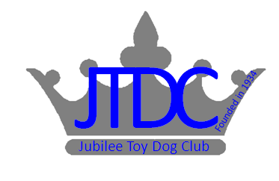

JUBILEE TOY DOG CLUB OF SOUTH AFRICA

OPEN SHOW

SUNDAY 21st JANUARY 2018at GOLDFIELDS KENNEL CLUB, BOEING RD BEDFORDVIEW.

JUDGE: MRS B. DEGENHARDT
STEWARD Mr Degenhardt Jnr

JUDGING COMMENCES AT 10h00AM

Enquiries Tracie Austen 072 839 0664 / jubileetoydogclub@gmail.com

Entry Fees: R45.00 per dog per class
Entries From: 09h00AM

Judging Order Alphabetical order

Breed Classes: Minor Puppy, Puppy, Junior, Graduate, SA bred, Open, Veteran, Champions, Baby Puppy then Neutered.
Challenges: BEST BABY PUPPY IN SHOW, BEST PUPPY IN SHOW, BEST JUNIOR IN SHOW, BEST VETERAN IN SHOW, BEST IN SHOW then BEST NEUTERED IN SHOW

Show Manager: Andre Rademeyer
Honorary Vet Surgeon: Dr R. Ehrlich

Contact:
Chairman: Anita Rademeyer
Vice Chairman: Andre Rademeyer
Secretary: Tracie Austen
Treasurer: Anita Rademeyer

RIGHT OF ADMISSION RESERVED

This show will be held under the Rules and Regulations of the Kennel Union of Southern Africa.

“All Exhibitors/Handlers are personally responsible for the control of their dogs at all times and shall be personally liable for any claims which may be made in respect of injuries which may arise or be caused by their dogs. All Exhibits must be on leads at all times unless otherwise instructed by a Judge.“

