THE WORKING AND HERDING BREEDS CLUB OF THE CAPE

NON-CHAMPIONSHIP SHOW
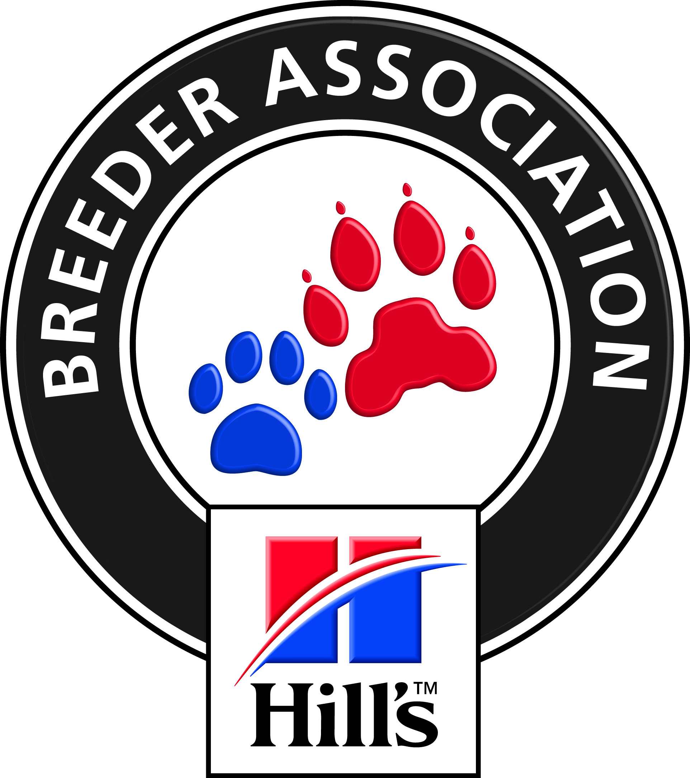

SUNDAY 29th JULY 2018

AT CANNONS CREEK SCHOOL SPORTS FIELD, PINELANDS

Enquiries: Hon Secretary, Mrs Hella Fricke: Tel: 076 170 7218 Fax: 086 218 9877
PO Box 59, Koelenhof 7605 email: whbc@telkomsa.net

STARTING TIME: 10h00
JUDGE: Mr J Marques
Show Manager: Mr R Koning

ENTRIES TAKEN FROM 9h00 NON-MEMBERS: R 50-00 PER DOG
MEMBERS: R 40-00 PER DOG
SUBSCRIPTIONS ARE NOW DUE Single: R15-00 p.a. Family: R20-00 p.a.

CLASSES and ORDER OF JUDGING.
Note: The Working and Herding Breeds are combined.

BABY PUPPY 4 to 6 months
MINOR PUPPY 6 to 9 months
PUPPY 9 to 12 months
JUNIOR 12 to 18 months
VETERAN Dogs over 7 years old

PLEASE NOTE: All Exhibitors/Handlers are personally responsible for the control of their dogs at all times and shall be personally liable for any claims which may be made in respect of injuries which may arise or be caused by their dogs.

RIGHT OF ADMISSION RESERVED

SPONSORED BY
Hill’s Pet Nutrition

