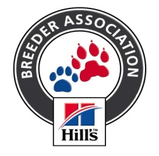
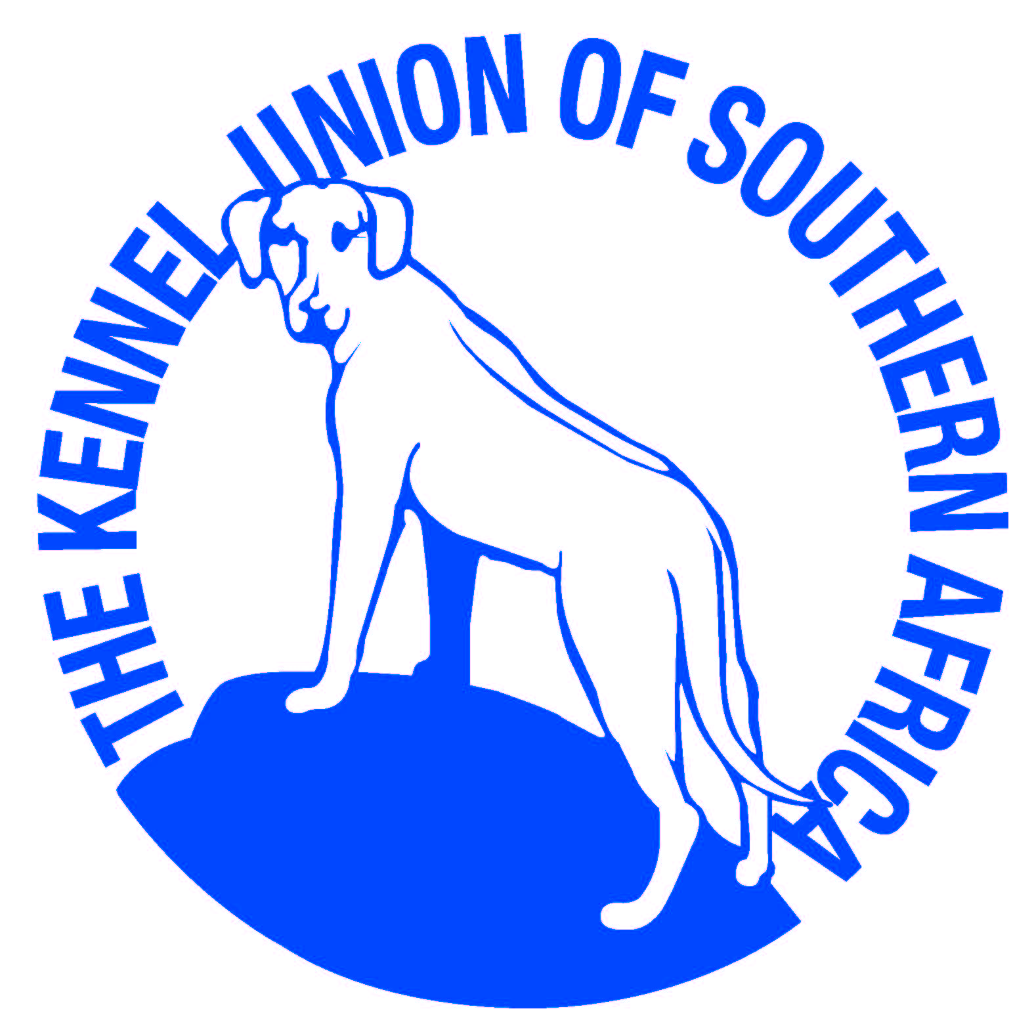

Hottentots Holland Kennel Club

K C
Affiliated to the Kennel Union of Southern Africa

ALL BREED CHAMPIONSHIP SHOW

Date of Show : Saturday, 26th October 2019
Show Venue: Brackenfell Cricket Club
Closing date for Entries : Final cut off Monday 13th October 2019 No late entries after this date
Only Members of the Kennel Union shall be entitled to enter dogs in their registered ownership in any Championship Dog Show licensed by the Kennel Union

Judging Times: | 08.30 Child & Junior Handlers  09.00 Breed
Entry Fee: | R 120.00 per dog for the first two dogs entered under the same owners name  R 60.00 per dog there after  R 85.00 for Baby Puppies/ Neuters  Child & Junior Handlers - No charge (dogs to be entered in a breed class)  Please note: Please add R30.00 for cash payments to cover bank charges
Catalogue: | R 80.00 - Group only. To be ordered and paid for with show entry
Trade Stalls: | R200.00 per Stall - to be booked and paid for by close of entries
Entry Instructions: | - Incorrect and illegible entries will not be processed  - All entries emailed or faxed to be sent together with the deposit slip with surname as reference. Not the dog’s name or show entry or the date of the show  - Money deposited will not be refunded
Entries & Enquiries: | Enquiries: 082-5214374/071-4922507 Fax 021-9818099 or email: proamacs@gmail.com
Banking details: | Bank / branch: ABSA  Account Name: Hottentots Holland Kennel Club  Account Number: 710631018 Code: 334712
Show Manager: | Mrs B Gillatt
KUSA Representative: | Mrs D Powell
Vet on call: | Dr James Jackson (Die Boord Animal Clinic)
Breed Classes: | Baby Puppy (4-6 months) /Minor Puppy (6–9months) / Puppy (9 –12months) / Junior (12– 18months) / Graduate (18 – 24 months) / Veteran (7 yrs +) / Open / Champions, Neuter  Please note: The Baby Puppy class will be judged after Best of Breed.  Winners of the Baby Puppy Class and Neuter are not eligible for the CC or Best of Breed but go forward to Best Baby Puppy / Neuter in Group and Show

JUDGES
GUNDOGS | MR J TARR | SOUTH AFRICA
HERDING | MRS E RAUBENHEIMER | SOUTH AFRCA
HOUNDS | MS L NIEMANN | AUSTRALIA
TERRIERS | MR C MOORE | AUSTRALIA
TOYS (Toys will follow Utility) | MR S FRISK | SWEDEN
UTILITY | MR S FRISK | SWEDEN
WORKING | MR T HORCHNER | AUSTRALIA
BEST BABY PUPPY, BEST NEUTERED DOG, PUPPY, JUNIOR, VETERAN AND IN BEST IN SHOW | MR C MOORE | AUSTRALIA
HANDLERS (Child & Junior) | Mrs E RAUBENHEIMER | SOUTH AFRICA
Order of Judging will be Baby Puppy in Show, Neuter, Veteran, Junior, Puppy and BIS
- All Breeds will be judged in alphabetical order as listed in appendix A of schedule 2 of the KUSA constitution.
- All exhibitors / handlers are personally responsible for the control of their dogs at all times and shall be personally liable for
any claims which may be made in respect of injuries which may arise or be caused by their dogs.

Vehicles will not be allowed onto the field. The show will not commence until every vehicle is off the field.

The person/s responsible for any damages made to the venue, grounds and /or irrigation system will be liable for the cost thereof. Conditions attracting immediate disqualification are set out in Schedule 3, Reg. 7 & 31.

Puppies under four (4) months are not eligible for entry.
- Rings will be set up by 3pm on Thursday 24th October, after which gazebos can be erected

RIGHT OF ADMISSION RESERVED. Bitches in season will be permitted in Breed only. The mating of Bitches within the precincts of the show is forbidden

This Show is Sponsored by Hills Pet Nutrition

