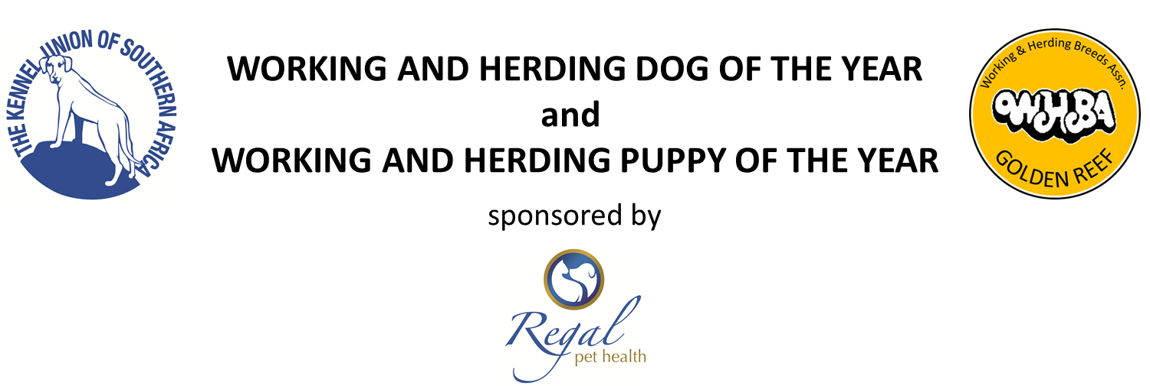
Entries are invited to the above competition which is open to all Working and Herding Breeds that have won a Best of Breed, Reserve Best of Breed or Best Puppy at all breeds Championship Shows in Gauteng ONLY from 18 August 2018 to 12August 2019.
ADMIN CHARGES R50, REFUNDABLE IF DOG DOES NOT QUALIFY
Best of Breed: 3 points Reserve Best of Breed: 2 points
Highest number of points in each breed qualifies. Highest number of Best Puppies qualifies.
Fax 086 626 9971 Email workingandherding@gmail.com
PLEASE DO NOT SUBMIT PHOTOCOPIES – IF WE NEED THEM WE WILL ASK

I wish to submit an application for my Dog/Bitch
NAME:______________________________ SEX:______________________________
BREED:_____________________________ KUSA REG. NO.:_______________________________
to be considered as a qualifier for the Working & Herding Breeds Association Golden Reef Dog/Puppy of the Year.
SHOW BEST OF BREED RES BEST OF BREED BEST PUPPY
_________________________________ ____________ ____________ ____________
_________________________________ ____________ ____________ ____________
_________________________________ ____________ ____________ ____________
_________________________________ ____________ ____________ ____________
_________________________________ ____________ ____________ ____________
_________________________________ ____________ ____________ ____________

NAME (print in full):___________________________ SIGNED:__________________________
ADDRESS:_____________________________________________________________________________
TEL (H)______________________ (W)______________________ (CELL)________________________

