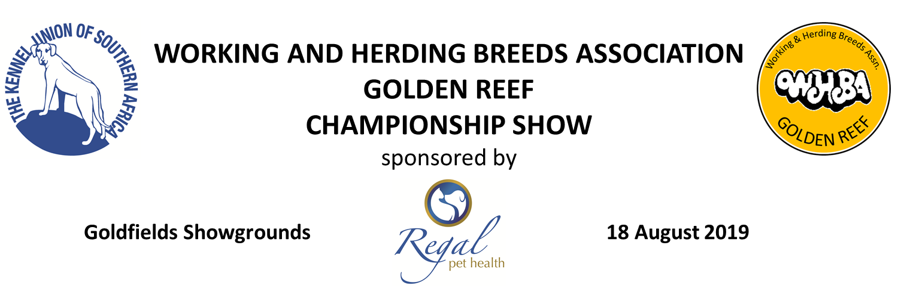
CLOSING DATE | 12 AUGUST 2019
STARTING TIMES | Breed 08:00  Obedience 08:00  Agility Contact 08:00, followed by Non-Contact  Dog Jumping 08:30
ENQUIRIES | Cathy Young 0834687970 | Kevin Young 0732235113
EMAIL | workingandherdingbreeds@gmail.com
FAX | 0866269971
BANKING DETAILS | FIRST NATIONAL BANK  BRANCH CARLSWALD 250117  ACCOUNT NUMBER 62710086647
ENTRIES | BREED R120 per dog per class  AGILITY AND DOG JUMPING R80 per dog per event, same dog in two events R140, same dog in three events R200  OBEDIENCE AND CARTING R90  Please add R30.00 to each cash deposit to cover bank charges. Please include your email address on your entry forms.
CLASSES | Minor Puppy, Puppy, Junior, Graduate, SA Bred, Veteran, Open, Champion, *Baby Puppy, *Neuter (*not eligible for CC or BOB)
OFFICIALS | Chairman Kevin Young  Vice Chairman and Show Manager Peter Dinsmore  Show Secretary Cathy Young
VET ON CALL | Bedfordview Veterinary Hospital
ORDER OF JUDGING | GROUPS: Group, Puppy, Junior, Veteran, Baby Puppy, Neuter  FINALS: Best in Show, Best Puppy in Show, Best Junior in Show, Best Veteran in Show, Best Baby Puppy in Show, Best Neuter in Show

BREED JUDGES |  | DISCIPLINE JUDGES
WORKING GROUP | Jan van Rijswijk | Beginners and B Class | Nancy Pelser
HERDING GROUP | Roy Clark | Novice and A Class | Mrs Leila Hakulinen
ALL BEST IN SHOWS | Jan van Rijswijk | C Class | Mr Hans Johansson
 |  | Agility Contact | Noelene Pretorius
 |  | Agility Non-Contact | Noelene Pretorius
 |  | Dog Jumping | Sue van de Pijpekamp
 |  | Carting | Mrs Yvonne Taentzer

DOG and PUPPY OF THE YEAR – SEE DETAILS BELOW
This show is held under the Rules and Regulations of the Kennel Union of Southern Africa. SCH (3) REG 5.9.
ONLY MEMBERS OF THE KENNEL UNION SHALL BE ENTITLED TO ENTER
- Bitches in season will be allowed to compete in breed classes only. Due consideration is to be given to competitors in obedience and agility. PLEASE REMEMBER YOUR CARDS!!
- Owners/Handlers must ensure that their dog(s) are strictly supervised at all times. Working & Herding Breeds Association Golden Reef will not be held responsible for any claims resulting from injury or damage caused by dogs present at the Show.
RIGHT OF ADMISSION RESERVED

