LABRADOR RETRIEVER KENNEL CLUB
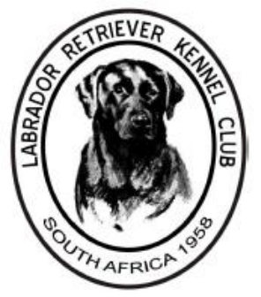 | (AFFILIATED TO THE KUSA)  Kindly sponsored by Montego Pet Nutrition  SECOND OPEN SHOW 2019  SATURDAY 22nd JUNE 2019  VENUE: GOLDFIELDS KENNEL CLUB SHOW GROUNDS  JUDGE – Mr Kevin Young  Ring Steward – Mr Johnny de Souza  Show Manager – Mr Dwayne Malcolm  Show Secretary – Mrs Sandy Borralho | 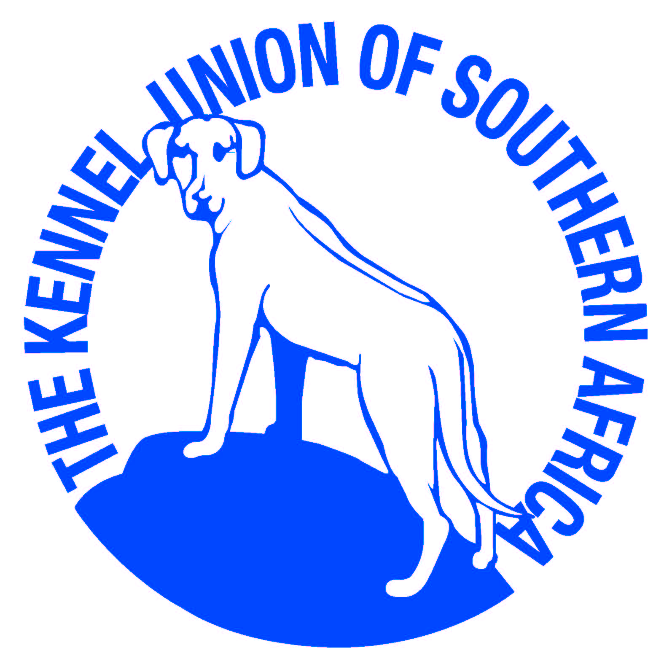

ENTRIES FROM 08:00, JUDGING STARTS AT 10:00
Entry fee: R50.00 per entry for first two entries and R45.00 per entry thereafter

RINGCRAFT TRAINING FOR NOVICE HANDLERS TO BE CONDUCTED FROM 08H30 - ALL WELCOME

ORDER OF JUDGING & CLASSES:
JUNIOR CLASSES (at 10am)  (DOGS WILL BE JUDGED FIRST FOLLOWED BY BITCHES)  Baby Puppy (4 – 6 months)  Minor Puppy (6 – 9 months)  Puppy (9 – 12 months)  Junior (12 – 18 months)  Graduate (18 – 24 months)  Maiden (dogs that have not won a prize at any Championship show)  BEST PUPPY  BEST JUNIOR | SENIOR CLASSES (after Junior Classes)  (DOGS WILL BE JUDGED FIRST FOLLOWED BY BITCHES)  Novice (dogs that have not won a first prize at any Championship show)  South African Bred  Veteran  Open  Champion  BEST VETERAN; BEST SA BRED;  BEST SENIOR  BEST IN SHOW (SENIOR VS JUNIOR)  Neuter Dogs

CHALLENGE CLASSES
(Free entry if exhibit entered in at least one breed class, otherwise above entry fee payable)
108 – Obedience Challenge
Best Head; Best Tail; Best Coat; Best Feet
___________________________________________________
ENQUIRIES: Sandy Borralho 082 330 9092
TROPHIES, ROSETTES AND SPONSORED FOOD PRIZES!!
Unfortunately, no refreshments offered for sale by the LRKC at the show..

RIGHT OF ADMISSION RESERVED.
All exhibitors/handlers are personally responsible for the control of their dogs at all times and shall be personally liable for any claims which may be made in respect of injuries which may arise or be caused by their dogs.

