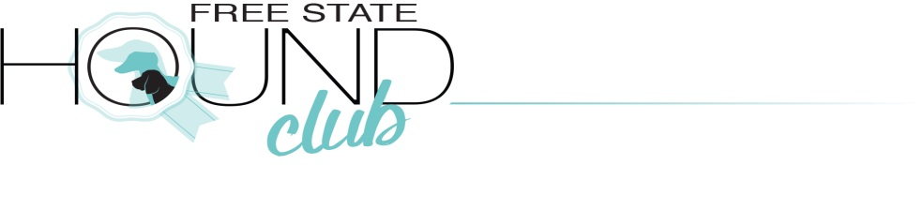
Qualifying show proudly sponsored by

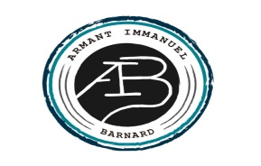
9.00 AM 16th March 2019
Entries – closing date 2 March 2019
Judge – Mr Neil Kay – Gauteng
Show Manager: L SmookRing Steward: M Beckman KUSA Rep: TBA
Venue – GJ Human Sport grounds, Church Street, Frankfort, Free State
Benching- Undercover benching available, no gazebos needed. The show will take place in a marquee tent. Just bring own chair
Breed Classes – Minor Puppy, Puppy, Junior, Graduate, Veteran, SA Bred, Open, Champions.
Baby Puppy & Neutered Dog after BOB & not eligible for BOB.
Handlers – Child and Junior Handling- R50. All handlers must be entered into a breed class (KUSA Regulations- Schedule 5K, Reg.3.5)
Order of Judging: Breeds in alphabetical order
Judging of BIS: Baby puppy, Puppy, Junior, Veteran, Neuter dog, Best in Show
Entry fees – Breed classes R70 per dog, Baby Puppy & Neutered Dog R60
- Members R60 per dog for first 2 dogs then R50 per dog
- Catalogue available for R20 (please add entry fee)
Official Kennel Union Challenge Certificates and Reserve Challenge Certificates, Best Puppy of breed, Best of Breed and Reserve Best of Breed Certificates shall not be awarded at a Qualifying show (KUSA Schedule 4A)
Only members of the Kennel Union shall be entitled to enter dogs in their registered ownership in any Championship Dog Show licenced by the Kennel Union.
Banking Details: Free State Hound Club, Standard Bank, Acc nr 147311934, Branch 055333
Please email entries with POP to: freestatehoundclub@gmail.com. Reference: Surname
**Only entries received with Proof of Payment will be accepted. No postal entries.
**Add R20 for cash payments and R30 for Cheque Payments
Catering - Catering & full bar available at the venue.
Enquiries – 0824558860 or 0828287470, email - freestatehoundclub@gmail.com
Officials – Chairman/Sec Taute, Hon Treasurer: H Taute,
Vet on Call Frankfort Diere Kliniek 058 813 1044

No parking on the field, only for on and off loading. Parking at the back of the pavilion.
This show is held under KUSA rules & regulations. The committee reserves the right to appoint an alternative judge if necessary. It is the responsibility of the exhibitor to ensure that dogs are under control at all times and shall be personally liable for all claims which may arise through damage or injury thereby. All dogs must be kept on leads at all times. Bitches in season are allowed but due consideration must be given by handlers to other dogs in the ring & surrounds. Right of admission reserved.
Only dogs being exhibited are allowed on the grounds.
Fantastic Prizes up for grabs and Goody Bags for all exhibitors.

