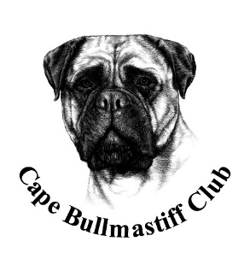

OFFICIAL SHOW SCHEDULE FOR THE NINTH CAPE BULLMASTIFF CLUB ANNUAL TROPHY SHOW TO BE HELD 26TH JANUARY 2020
Affilated to KUSA
This Speciality Show will be held at Zimzala Canine Estate
(R44 between Somerset West & Stellenbosch)
Date : 26th January 2020 commences 07h30
Judge: Mrs Monique Hodgkinson # 143436
Steward: Hannelie Basson # 1005030
Breed Classes: Baby Puppy 4-6 months (not eligible for BISS), Minor Puppy 6-9 months, Puppy 9-12 months, Junior, Graduate , Veteren, SA Bred & Champion.
Challenges to be done after BISS : Best Head, Best Bite, Best Handler, Best Red/Fawn/Brindle& Best Champion
Entry fees for members: R55 for first dog then R50 thereafter. Non members R60.
Entries may be submitted on the day 06h00 to 07h30 or before time. Payment on the day.
Show manager : Nicky Robertson # 68120/ Show Secretary San Schmutz # 1025368
Vet on call for Bullmastiffs : Stellenbosch Animal Hospital
Right of Admission reserved
ALL EXHIBITORS ARE PERSONALLY RESPONSIBLE FOR THE CONTROL OF THEIR DOGS AT ALL TIMES AND SHALL BE PERSONALLY LIABLE FOR ANY CLAIMS WHICH MAY BE MADE IN RESPECT OF INJURIES OR BE CAUSED BY THEIR DOGS.
SPONSORSHIP: UCN
Enquires: Nicky Robertson info@capebullmastiffclub.co.za0829239702

