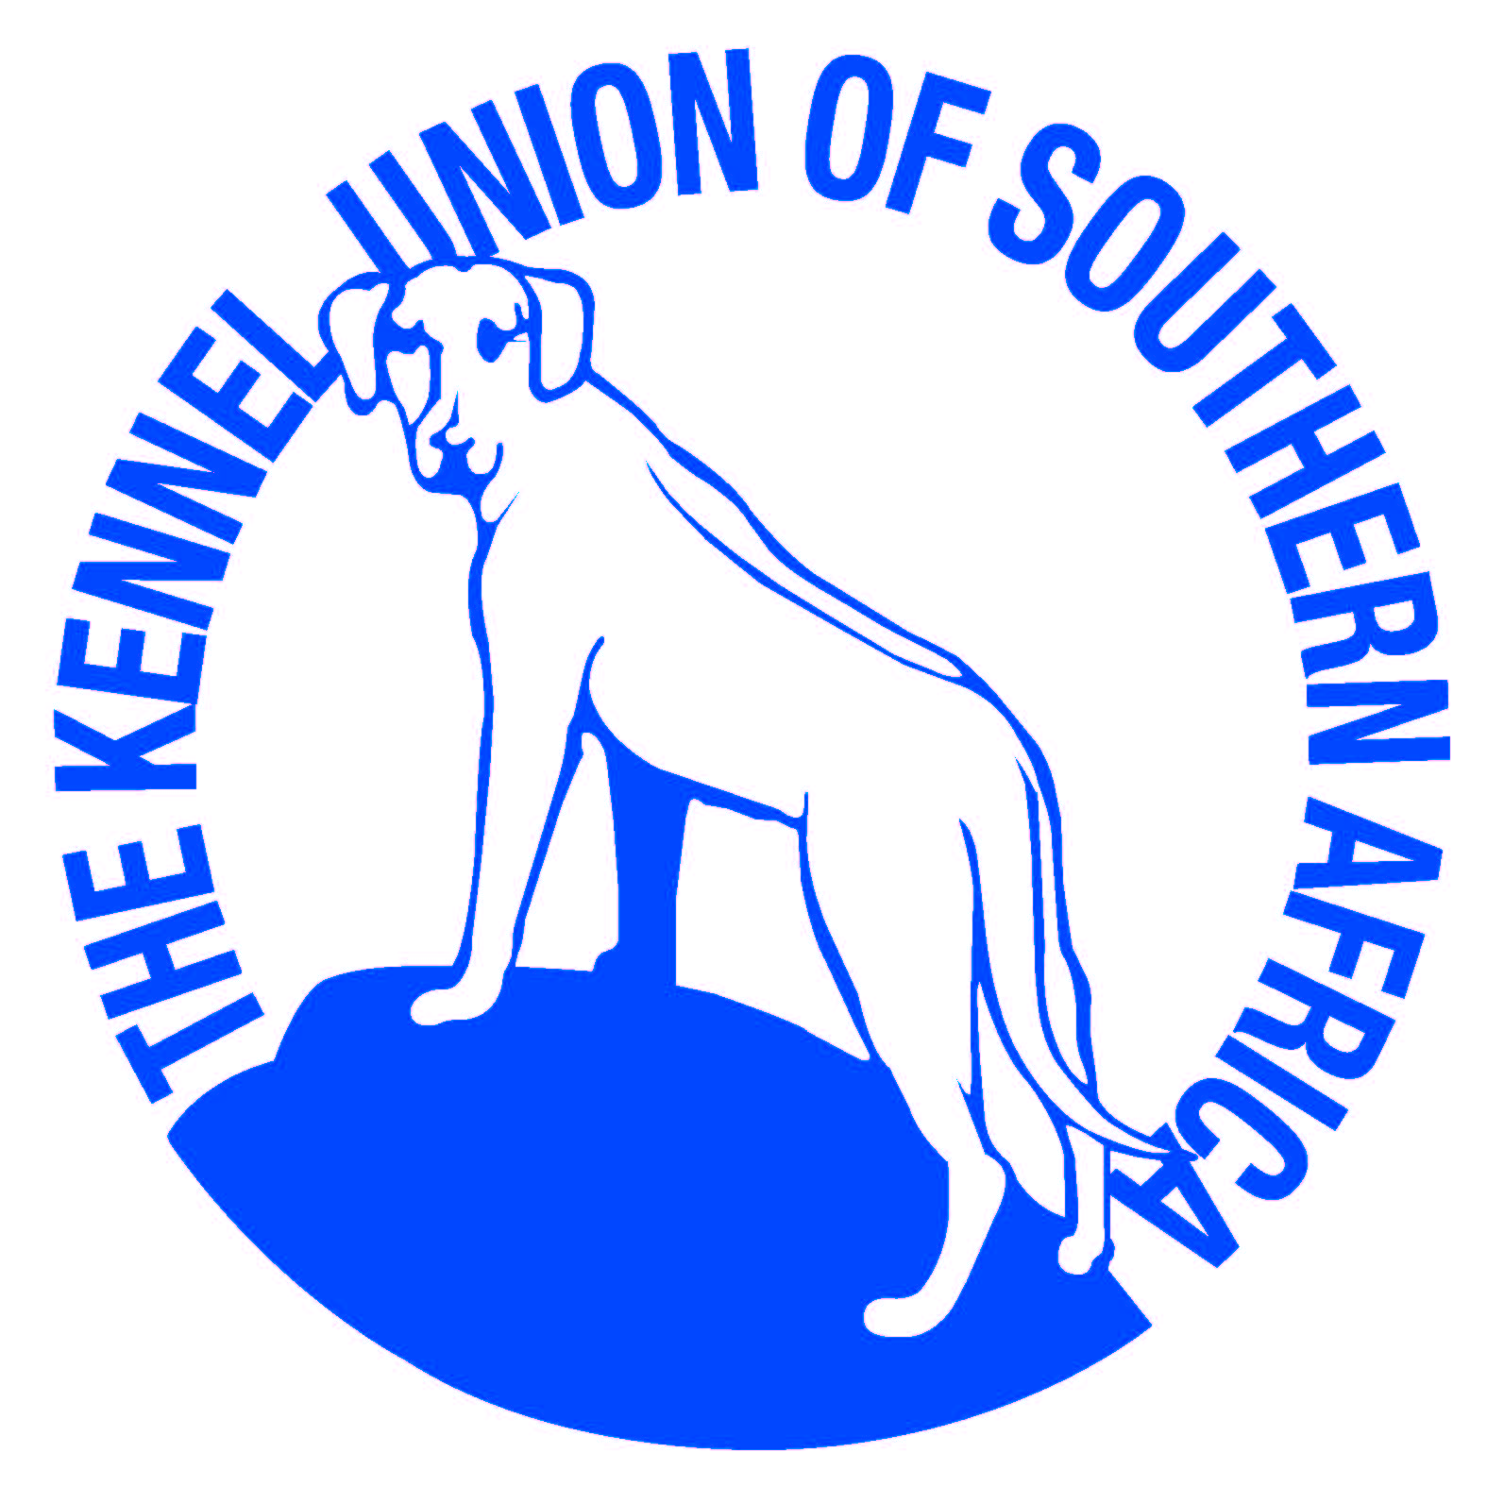

2nd Championship Show
Saturday 23 October 2021

Stellenbosch District Riding Club, off R44, Somerset West, Cape Town
Judging will start on completion of Australian Shepherds at Working and Herding breeds club of the Cape (but not before 11:00)

Judge: Sue Impey

Entries & Enquiries:
Melani Parkin 076 104 2726 aussieclubwc1@gmail.com

Entry fees: Non-members R130-00 Members R110-00
Catalogue: R 40.00 to be paid with entry
Club membership fees: Single R60.00 Family R100.00
Child and Junior Handlers: Free, but dog must be entered in a breed class at this show.

Banking Details: ABSA Bank, Savings Account No: 9347 360 459, Branch: Table View

Entries Close: 13 October 2021

Breed Classes: Baby Puppy, Minor Puppy, Puppy, Junior, Graduate, SA Bred, Veteran, Open, Champion, Neuter.
Child & Junior Handler: Child Handlers: 8 and under 11 years and Junior Handlers: 11 and under 18 years of age. Please send copy of proof of age with entries.

Judging order: All dog classes except Baby Puppy &Neuter, followed by all Bitch classes except Baby puppy.
Followed by Best of Breed, Reserve Best of Breed, Best Puppy, Best Junior, Best SA Bred.
Followed by Baby Puppy Dog , Baby Puppy Bitch, Best Baby Puppy, Neuter

COVID PROTOCOLS TO BE STRICTLY APPLIED.
Completed Covid-19 disclaimer form to be handed in at the gate.
Masks must be worn and social distancing practiced at all times
All entries must be accompanied by a deposit slip with surname as reference. Numbers will be emailed.
Please complete the Covid-19 disclaimer form, for each person on the show day and hand it in at the entrance gate.
Please make note of the number of people attending on the show on the entry form.
Please use the latest KUSA Official Show Entry form dated 01.08.2020.
The Club reserves the right to cancel or amalgamate classes, amend the prize list, return entries or replace the Judge should the need arise.

Chairman & Show Manager: Chris Nezar 064 012 0837
Vice Chairman: Lorish Olivier 082 698 2875
Secretary & Show Secretary: Melani Parkin 076 104 2726
Treasurer: Lizelle Nel 081 270 8342

COVID Compliance Officer: Lizelle Nel 081 270 8342
Deputy COVID officer: Anneen van Wyk 079 749 7371

Vet on Call: James Jackson: 021 887 3300

Steward: TBC

Notice to all Exhibitors

- All exhibitors/handlers are personally responsible for the control of their dogs at all times and shall be personally liable for any claims which may be made in respect of injuries which may arise or be caused by their dogs.
- The committee reserves the right to change the judge should the need arise.
- No refunds will be made for any errors made by the owner/exhibitor.
- Conditions attracting immediate disqualification may be found in Schedule 3,regs 7&31
- Exhibits to be on leads at all times unless otherwise instructed by the Judge.
- This show is held under the Rules& Regulations of the Kennel Union of Southern Africa.
- Bitches in season are permitted.
- The mating of bitches within the precincts of the show is forbidden.
- Conditions at attracting immediate disqualification are set out in Regulations 7&31of Schedule3.
- Baby puppy breed class & Neuter are not eligible for CC or BOB.
- Puppies under 4 months are not eligible for exhibition.

RIGHT OF ADMISSION RESERVED

