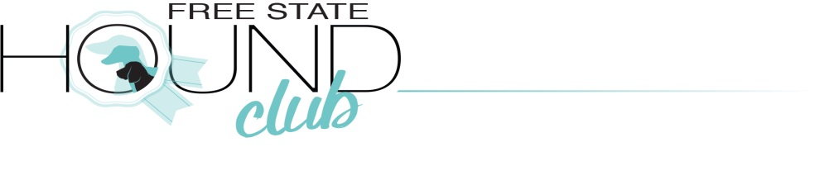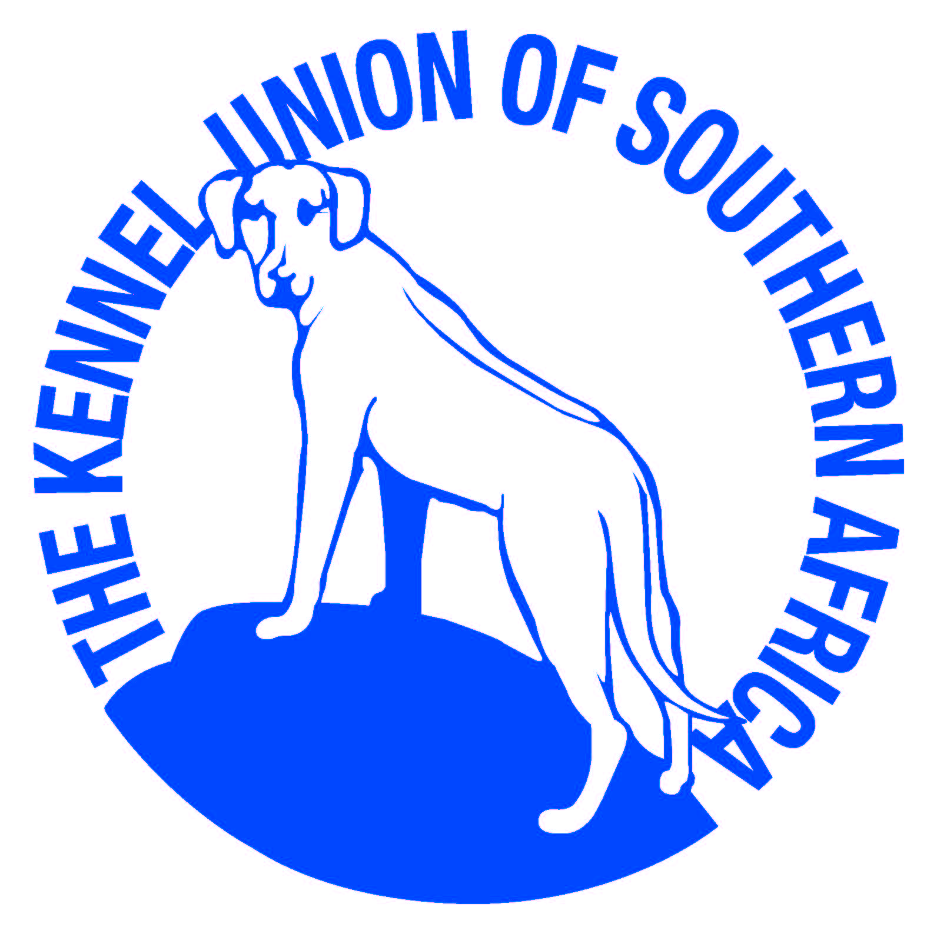
Championship show proudly sponsored by

9.00 AM 13th March 2021
Entries – closing date 3 March 2021
(ABSOLUTELY NO LATE ENTRIES WILL BE ACCEPTED!!)
Judge – Brenda Degenhardt (Gauteng)
Show Manager: J JacksonRing Steward: TBA
COVID-19 Officer: H Taute, Deputy COVID-19 Officer: P Jarvis
Venue – HoerskoolWilgerivier Sport Grounds, Frankfort, Free State
Benching- Undercover benching available, no gazebos needed. The show will take place in a marquee tent. Just bring own chair
Breed Classes – Minor Puppy, Puppy, Junior, Graduate, SA Bred, Veteran, Open, Champion, Neuter*, Baby Puppy*.
*Baby Puppy and Neuter after BOB & not eligible for BOB.
*Puppies under four months are not eligible for exhibition
****Handlers – NO HANDLER CLASSSES ON OFFER.*****
****Miniature Dachshunds will not be weighed due to COVID-19***
Order of Judging: Breeds in alphabetical order
Judging of BIS: Neuter, Baby puppy, SA Bred, Puppy, Junior, Veteran, Best in Show
Entry fees - Breed classes R130 per dog, Baby Puppy& Neuter R100
- Members R110 per dog.
- Catalogue available for R30 (please add entry fee)
- Only the official KUSA Entry form (01.10.2020) may be used
- No RAF/TAF entries are permitted
Only members of the Kennel Union shall be entitled to enter dogs in their registered ownership in any Championship Dog Show licenced by the Kennel Union.
Conditions attracting immediate disqualification are set out in Regulations 7 & 31 of schedule 3.
Please adhere to COVID-19 Rules & Regulations at all times!
Banking Details: Free State Hound Club, Standard Bank, Acc nr 147311934, Branch 055333
Please email entries with POP to: freestatehoundclub@gmail.com. Reference: Surname
**Only entries received with Proof of Payment will be accepted. No postal entries.
**Add R20 for cash payments and R30 for Cheque Payments
***NO ENTRIES WHITHOUT POP WILL BE ACCEPTED OR VICE VERSA****
Catering - Catering & full bar available at the venue.
Enquiries – 0824558860 or 0828287470, email - freestatehoundclub@gmail.com
Officials – Chairman: J Taute, Hon Treasurer/ Secretary: H Taute

Vet on Call Frankfort Diere Kliniek 058 813 1044

This show is held under KUSA rules & regulations. The committee reserves the right to appoint an alternative judge if necessary.

It is the responsibility of the exhibitor to ensure that dogs are under control at all times and shall be personally liable for all claims which may arise through damage or injury thereby. All dogs must be kept on leads at all times. Bitches in season are allowed but due consideration must be given by handlers to other dogs in the ring & surrounds. The mating of bitches within the precincts of the show is prohibited. Right of admission reserved.
Only dogs being exhibited are allowed on the grounds.
Fantastic Prizes up for grabs and Goody Bags for all exhibitors.

