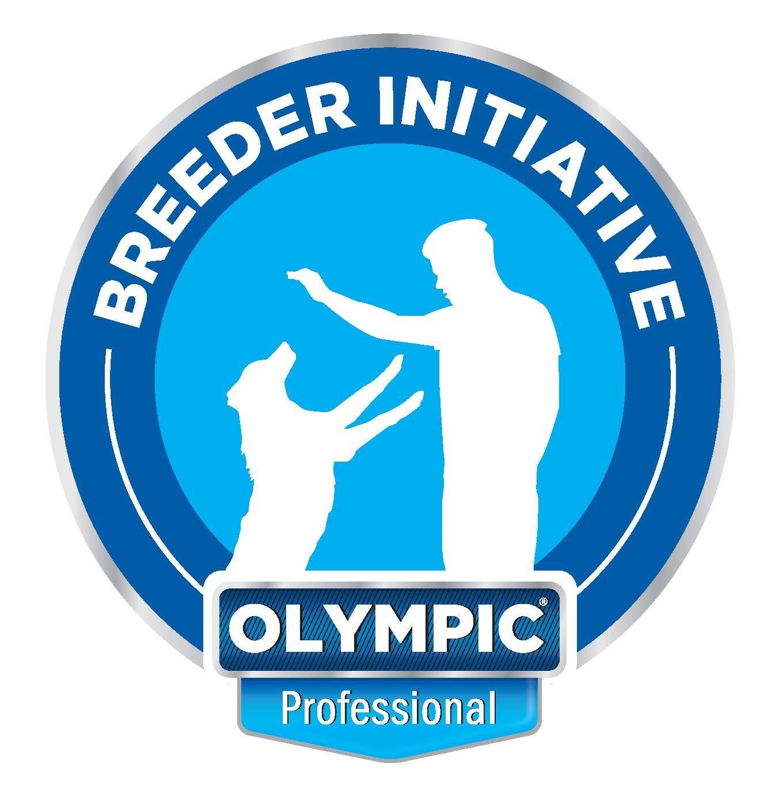

WESTERN GAUTENG KC. 56TH ANNUAL CHAMPIONSHIP SHOW
GOLDFIELDS SHOW GROUNDS, BEDFORDVIEW, SATURDAY 6 NOVEMBER, 09H00

SHOW ENTRY DETAILS
CLOSING DATE FOR ENTRIES: WEDNESDAY 27 OCTOBER 2021
ENTRIES TO: westernskc@gmail.com
Please bring a copy of your entry form and POP to the show, to resolve any queries.
ENTRY FEES:
Minor puppy, Puppy, Junior, Graduate, SA Bred, Open, Champions: R140,00 per dog, per class
Baby Puppy (not eligible for CC or BOB), Veterans: R80,00 per dog, per class
BANKING DETAILS:
Western Gauteng KC: ABSA Bank, Edenvale, Account Number: 01 008 550 740 Branch Code: 507442
Please note that NO entries will be accepted without proof of payment. BANK REFERENCE MUST BE THE REGISTERED OWNER’S SURNAME.
Please add R30 for cash or cheque deposits to cover our bank charges
GROUP | JUDGES
Gundogs & Group | Renier Jansen van Vuuren
Herding & Group | Michele van Vuuren
Hounds & Group | Franklin van der Spuy
Terriers & Group | Liz Megginson
Toys & Group | Avril Ventress
Utility & Group  NB. FRENCH BULLDOGS 09H00 | Mildred McCluskey. Balance & Group  Liz Megginson
Working & Group | Rob Forsythe
Best in Shows | Avril Ventress
Child & Junior Handling 09H00 | Randolph de Taranto
Order of Judging: | Groups: BIG, BPIG, BBPIG, BJIG, BVIG. Best in Shows: BBPIS, BJIS, BVIS, BPIS, BIS

Chairman & Show Manager: Randolph de Taranto,
Show Secretary: Glenda de Taranto 083 312 1038
Vet on Call: Dr Rochelle Ehrlich

COVID-19 Protocols & Procedures are found on the following page.

Unless stated to the contrary, breeds will be judged in alphabetical order, as listed in Appendix A of Schedule 2 of the KUSA Constitution. Dogs incorrectly entered will be placed in the Open Class. No entries marked TAF or RAF will be accepted. Exhibitor numbers will not be posted, but are to be collected on the morning of the Show. The Club reserves the right to appoint alternate judges should any of the above be unable to officiate. In terms of Schedule 3, Reg 5.8.1, please note that puppies under 4 months are not eligible for entry. In terms of Reg 5.10.1 all Exhibits must be present 30 minutes prior to commencement. Exhibitors/Handlers are responsible for the control of their dogs and shall be personally liable for claims for injuries/damages caused by their dog/s. The show will be conducted under the rules and regulations of the Kennel Union of Southern Africa. ONLY MEMBERS of the Kennel Union shall be entitled to enter dogs in their registered ownership in any Championship Dog Show licensed by the Kennel Union. The latest show entry form dated 01.08.2021 to be used
https:/kusa.co.za/index.php/events/show-documents/show entry forms. The mating of bitches in the precincts of the show is forbidden. Dogs are to be on leads at all times.

COVID-19 Protocols & Procedures will be observed at this event

- A maximum of 2000 people will be allowed at the venue at any one time if held outdoors, or 750 attendees if held indoors.
- All persons attending this event must wear a reusable cloth or sponge face mask, or a disposable surgical mask, except when running while handling a dog in competition. Face shields only are not legal. Any person not wearing a mask will be requested to leave the venue.
- All attendees must observe social distancing and, whenever feasible, maintain a distance of at least 1.5 metres between themselves and others with whom they don’t cohabit.
- Sanitiser will be available at the Organisers’ Office, on all Judges’ tables, at ring entrances and in the toilet areas.

Please note that by entering and/or attending this event, participants are agreeing to comply with any
instructions issued by the COVID-19 Compliance Officers, and that the organisers have the right to
request any person who refuses to comply with a request or instruction to leave the venue. Any person
found to be non-compliant may also be liable for disciplinary action under Schedule 1 of the KUSA
Constitution.

The above Protocols and Procedures are subject to immediate change in the event of either the Alert
Level, or the Government Regulations pertaining to COVID-19, being varied prior to this event.

THE COVID-19 COMPLIANCE OFFICERS AT THIS EVENT ARE:

COVID-19 Compliance Officer: Randolph de Taranto, 072 055 9633, #48223
Deputy COVID-19 Compliance Officer: Martine Wright 061 017 5691

