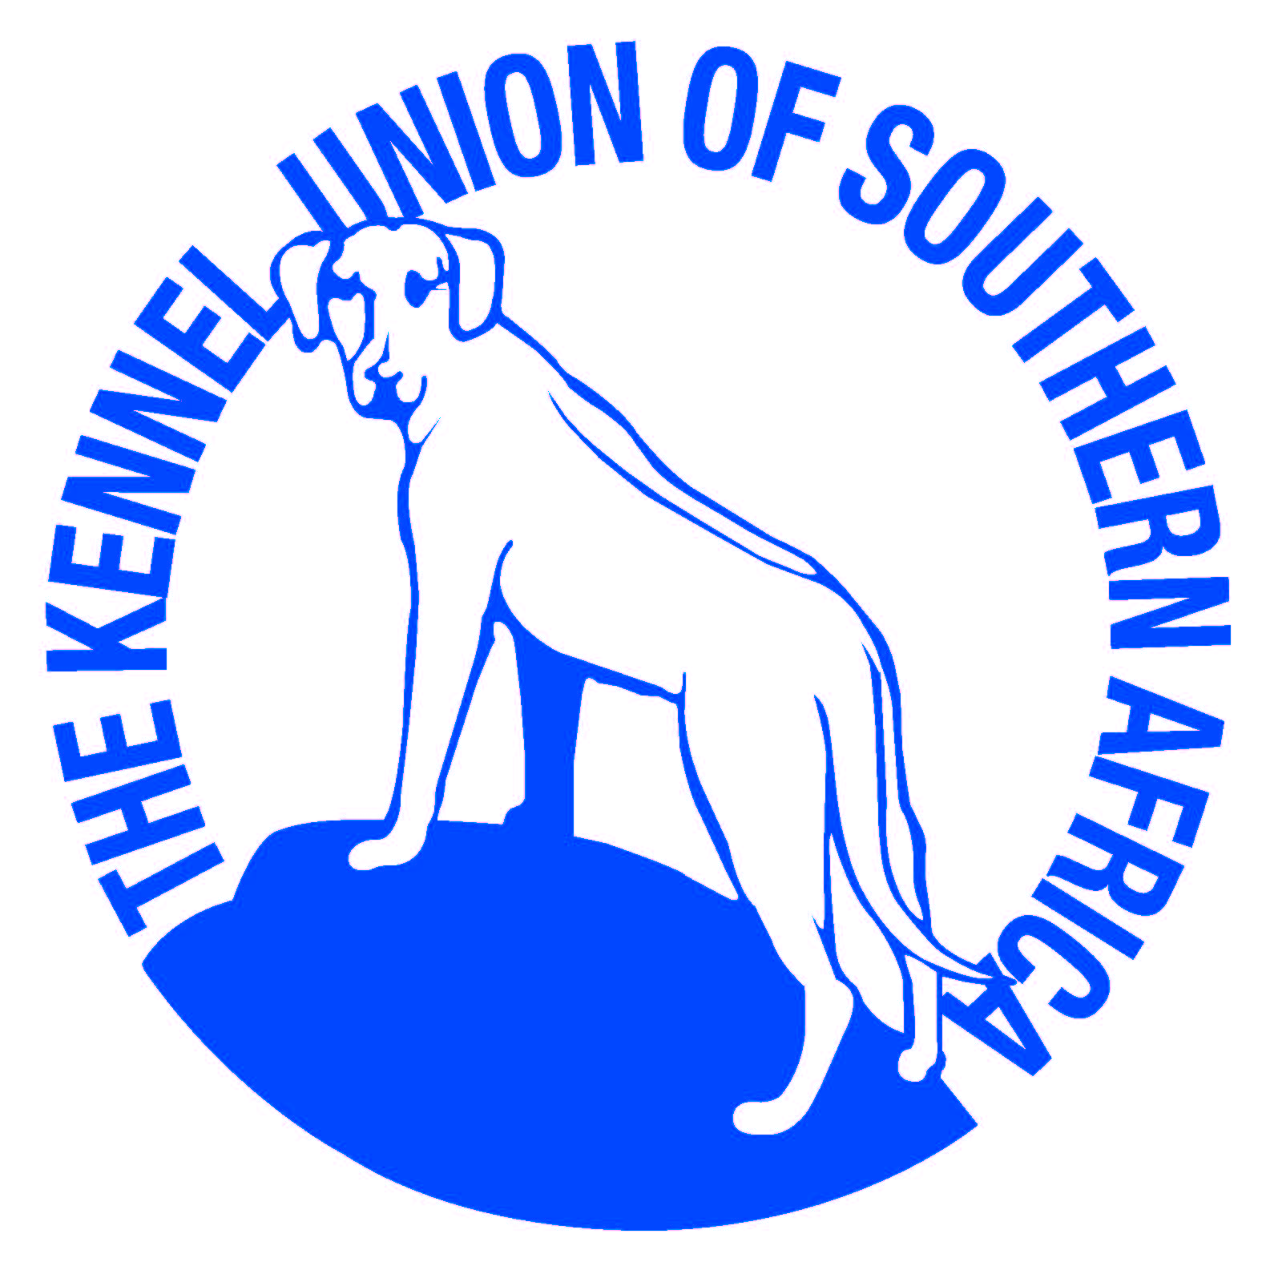 CAPE GUNDOG CLUB
ANNUAL CHAMPIONSHIP SHOW #1

DATE: SUNDAY 16 OCTOBER 2022
TIME: ON COMPLETION OF
CAPE TOWN KC GUNDOG GROUP
VENUE : HELDERBERG RUGBY CLUB
CHURCH STREET, STRAND

OFFICE BEARERS : | Chairman : Richard Hacking Secretary/Treasurer : Joan Whittingham  Vice Chairman: Rowena Wonfor Enquiries : Diane Hacking
SHOW MANAGER: | RICHARD HACKING STEWARD: JUDITH MUSTO
VET ON CALL : | STELLENBOSCH ANIMAL HOSPITAL
JUDGE : | MRS CARINE BUITENDACH (FS)
ENTRIES & ENQUIRIES : | Joan Whittingham: 083-3889880 Email: wham@iafrica.com  All entries must be accompanied by a deposit slip with surname as reference.  Numbers to be collected from 9am.  Please use the latest KUSA Official Show Entry form dated 01.01.2022.  The Club reserves the right to cancel or amalgamate classes, amend the prize list, return entries or replace the Judge should the need arise.
BANKING DETAILS : | Standard Bank, Blue Route Centre, TOKAI, Account No: 07 202 4968 Branch Code: 025 609
ENTRIES CLOSE : | Tuesday, 4 October 2022
ENTRY FEES : | Breed : Non-members: R170 Members: R150  Challenge : Non-members: R40 Members: R30 (if entered in a breed class)  Non-members: R210 Members: R180 (if not entered in a breed class)
CATALOGUE : | R70 to be paid with entry. Advertising available at R150 per full colour page.
BREED CLASSES : | BABY PUPPY : MINOR PUPPY : PUPPY : JUNIOR : GRADUATE :  SA BRED : VETERAN : OPEN : CHAMPION
CHALLENGE : | FIELD TRIAL (BITCHES IN SEASON NOT PERMITTED FOR THIS CHALLENGE)
JUDGING ORDER : | BREED: BEST OF BREED, PUPPY, JUNIOR, VETERAN, BABY PUPPY  FINALS: FIELD TRIAL, BEST IN SHOW, MINI GRAND, BABY PUPPY, PUPPY, JUNIOR, VETERAN.
CATERING : | Will be available all day.

Notice to all Exhibitors
- All Exhibitors/Handlers are personally responsible for the control of their dogs at all times and shall be personally liable for any claims which may be made in respect of injuries which may arise or be caused by their dogs.
- Breeds will be judged in alphabetical order as listed in Appendix A of Schedule 2 of the KUSA constitution.
- No refunds will be made for any errors made by the Owner/Exhibitor.
- Only Members of the Kennel Union shall be entitled to enter dogs in their registered ownership in any Championship Dog Show licensed by the Kennel Union.
- Bitches in season are permitted, except in the Field Trial Challenge.
- The mating of bitches within the precincts of the show is forbidden.
- Conditions attracting immediate disqualification are set out in Regulations 7 & 31 of Schedule 3.
- Baby Puppy breed class is not eligible for CC or BOB.
- Puppies under 4 months are not eligible for exhibition.

RIGHT OF ADMISSION RESERVED

