TECKEL CLUB
56th ANNUAL CHAMPIONSHIP SHOW
BREED & CARTING
INCORPORATING TECKEL OF THE YEAR COMPETITION
Date: 11 April 2021
Venue: Goldfields Kennel Club, Bottom Grounds, Clarkson Road

JUDGES:

BREED: Mrs HA Gouws – Start Time: 09h00

CARTING: Mrs S van der Molen - Start Time: 09h00

COVID PROTOCOLS TO BE STRICTLY ADHERED TO
Kindly complete the attached DISCLAIMER FORM.
This form is to be handed in at the gate on the day of the Show to gain access to the grounds.

Entries Close: 2 April 2021 Enquiries: Tracey Dorrington 072-174-0021
Entries to : teckelsa@gmail.com

PLEASE SEND PROOF OF DEPOSIT STATING YOUR NAME WITH ENTRIES
NB: Please add R20.00 per direct cash deposit to cover bank charges!! No postal orders accepted.

BANKING DETAILS:
Teckel Club, First National Bank, Woodmead, Branch No 250-955, Acc.No: 62420001365, Cheque Account

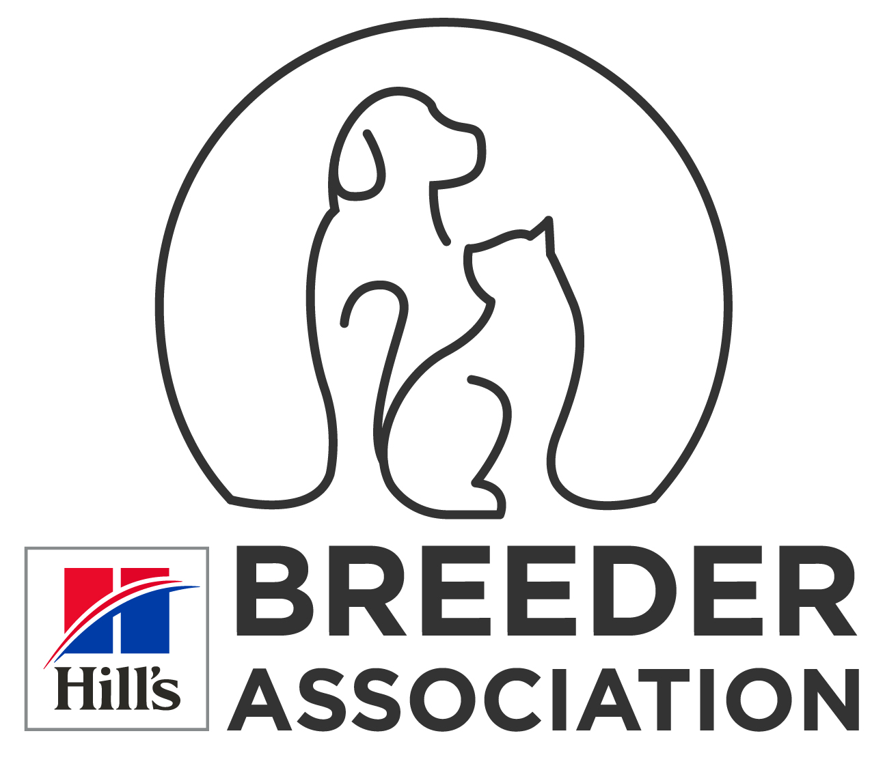
OFFICIALS
Patron : Mr R.B. Jenkins President: Mr. R.B. Jenkins
Chairman : Dr W.S. Jansen van Rensburg Show Secretary: Ms T.L Dorrington
Show Manager: Dr W S Jansen van Rensburg

VETERINARIAN ON CALL: Vorna Valley Animal Hospital

BEST IN SHOW, BEST PUPPY, BEST JUNIOR, BEST VETERAN, BEST BABY PUPPY AND BEST NEUTER DOG IN SHOW WILL BE JUDGED

Breed Classes: Baby Puppy, Minor Puppy, Puppy, Junior, Graduate, SA Bred, Members, Veterans, Open, Neuter Dog, Champions. -

Carting: Standard & Mini; Novice/Senior. All carting dogs to be older than 14 months.

Entry Fees: R90.00 per Dog/Class for first 2 dogs, thereafter R85.00 per dog/class – Breed & Carting
Catalogues: R 40.00 payable with entries.
Club Membership: R60.00 Single, R80.00 Double per annum.

Challenges: Breeders Team (FREE Entry - 3 or more Dogs bred, but not necessarily owned, by the Exhibitor). All dogs to be entered in a breed class.

Teckel & Teckel Puppy of the year: Will be judged immediately after completion of the breed show.
Judge: Mrs HA Gouws Dog or bitch in each variety with the most Best of Breed /Best Puppy certificates for 2020 will qualify. Entry free of charge. Please send copies of certificates to teckelsa@gmail.com for verification.

Order of Judging: 1) Dachshunds Long Hair 2) Dachshunds Miniature Long
3) Dachshunds Smooth Hair 4) Dachshunds Miniature Smooth Hair
5) Dachshunds Wire Hair 6) Dachshunds Miniature Wire Hair
Bitches in season will be allowed, but owners are, however, requested to show due consideration for fellow exhibitors. The mating of bitches within the precincts of the show is prohibited. Dogs/puppies not entered for exhibition are not permitted at the show grounds. No Entries marked R.A.F. or T.A.F. will be accepted. The conditions stipulated in the K.U.S.A. regulations 7 and 31 of schedule 3 attract immediate disqualification. All Exhibitors/Handlers are personally responsible for the control of their dogs at all times and shall be personally liable for any claims which may be made in respect of injuries which may arise or be caused by their dogs.

This show will be held under the rules and regulations of the KENNEL UNION OF SOUTHERN AFRICA
RIGHT OF ADMISSION RESERVED

